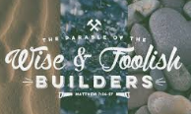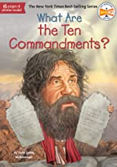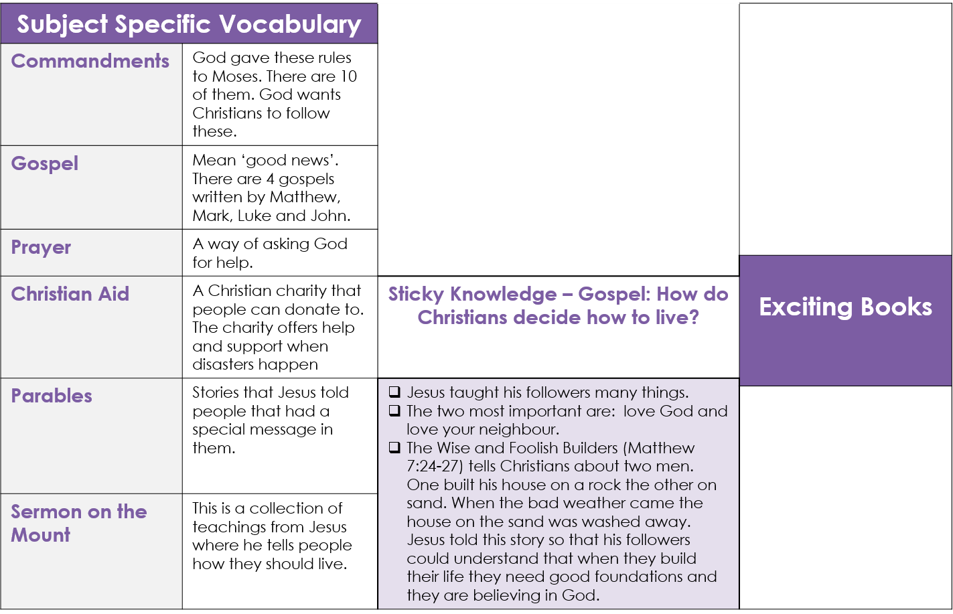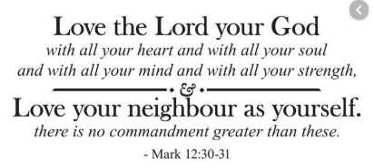

**Sticky Knowledge**

GREAT MOOR JUNIOR SCHOOL  
**“Learning Together”**

***Respect, Kindness, Tolerance,   
Responsibility, Co-operation***

**Christianity: Knowledge Organiser (Y5)**