Calculation Policy

Primary School
Calculations Policy
Introduction
Here at Great Moor Junior School children are introduced to the processes of calculation by building a sequence following a C-P-A approach. The C-P-A approach stands for Concrete - Pictorial – Abstract. This means that throughout the school, we see children using concrete equipment and pictures to support their understanding of more abstract concepts.
Over time children learn how to use models and images, such as Dienes, place value counters, bar models and tens frames, to support their mental and informal written methods of calculation. As children’s mental methods are strengthened and refined, so too are their informal written methods. These methods become more efficient and succinct and lead to efficient written methods that can be used more generally. By the end of Year 6 children are equipped with mental and written methods that they understand and can use correctly.
When faced with a calculation, children are able to decide which method is most appropriate and have strategies to check its accuracy. They will do this by asking themselves:
- Can I do this in my head?
- Can I do this in my head using drawing or jottings?
- Do I need to use a pencil and paper procedure?
At whatever stage in their learning, and whatever method is being used, it must still be underpinned by a secure and appropriate knowledge of number facts, along with those mental skills that are needed to carry out the process and judge if it was successful.
The overall aim is that when children leave primary school they:
- Have a secure knowledge of number facts and a good understanding of the four operations;
- are able to use this knowledge and understanding to carry out calculations mentally and to apply general strategies when using one-digit and two-digit numbers and particular strategies to special cases involving bigger numbers;
- make use of diagrams and informal notes to help record steps and part answers when using mental methods that generate more information than can be kept in their heads;
- have an efficient and reliable written method of calculation for each operation that children can apply with confidence when undertaking calculations that they cannot carry out mentally; which leads to a formal written method.

ADDITION
Year 3
Pupils should be taught to:
- add numbers mentally, including:
  - a three-digit number and 1s
  - a three-digit number and 10s
  - a three-digit number and 100s
- add numbers with up to 3 digits, using formal written methods of columnar addition
- solve problems, including missing number problems, using number facts, place value, and more complex addition

 | Concrete | Pictorial |  | Abstract
Recap on number bonds to 10, 20 and 100 | 3+7=10  12+8=20  30 + 70 =100  (relate to subtraction e.g. 10-3=7) | 3+7=10  12+8=20  30 + 70 =100  (relate to subtraction e.g. 10-3=7) |  | 3+7=10  12+8=20  30 + 70 =100  (relate to subtraction e.g. 10-3=7)  Also ensure children understand  even + even = even  Even + odd = odd  Odd + even = odd  Odd + odd = even
Addition of HTO + O (using bonds) | 123 + 5 = 128  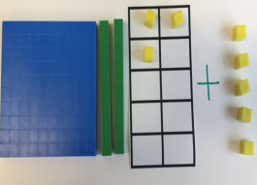 | 123 + 5 = 128  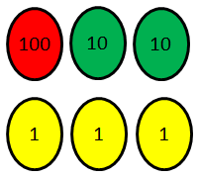  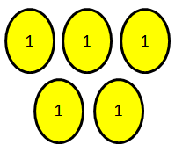  + |  | 123 + 5 = 120 + 8
Addition of HTO + O (crossing tens boundary) | 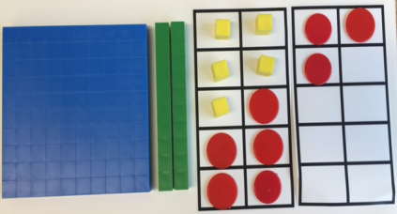  125 + 8 = 133 | 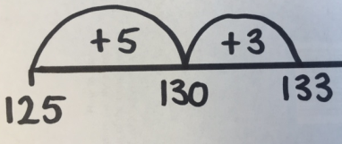  125 + 8 = 133 |  | 125 + 8 = 133  125 + 5 + 3 = 133
Addition of HTO + T (using bonds) | 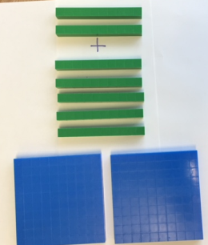  250 + 20 = 270 | 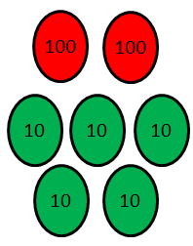  250 + 20 = 270  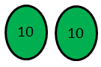  + |  | 250 + 20 = 200 + 70  Leading to any HTO + multiple of 10  (not crossing the ten boundary)  234 + 30 = 200 + 60 + 4
Addition of HTO + T (crossing tens boundary) | 278 + 50 = 328  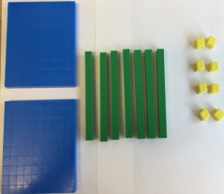  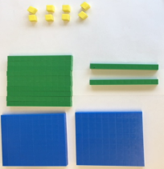  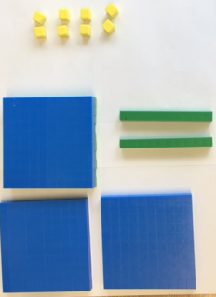  Children to understand the exchange of 10 tens for one hundred. | 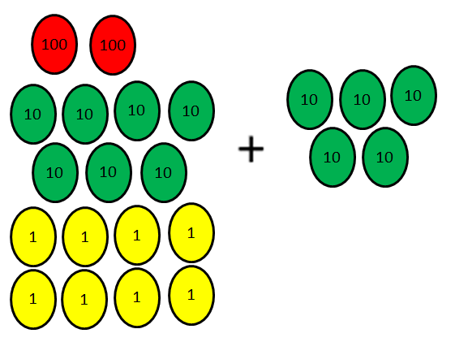  278 + 50 = 328 |  | 278 + 50 = 328  270 + 50 + 8 = 328
HTO + Hundreds | 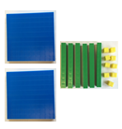  269 + 500 = 769  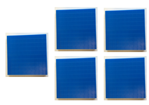 | 269 + 500 = 769  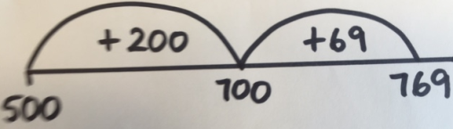 |  | 269 + 500 = 769  200 + 500 + 69 = 769
Addition of any TO + TO  Using partitioning | 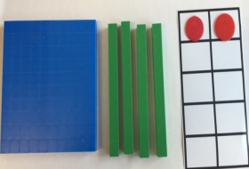  79 + 63 = 142  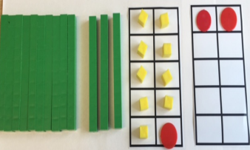 | 79 + 63 = 142  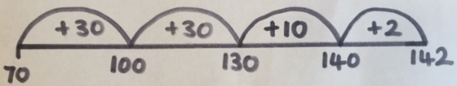 |  | 79 + 63 = 142  70 + 60 = 130  9 + 3 = 9 + 1 + 2  130 + 12 = 142
 | From Summer term of Year 3 formal methods of addition should be introduced to learners. Children should still have access to, and continue to use both concrete resources and visual representations when necessary.
Addition of two numbers (up to three digits) using columnar addition  Expanded vertical method | 358 + 24 = 382  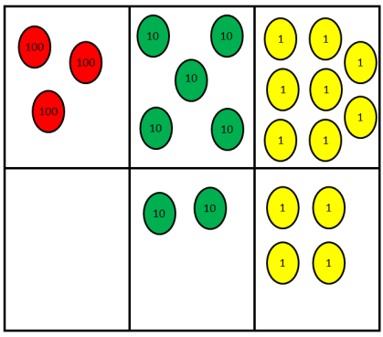  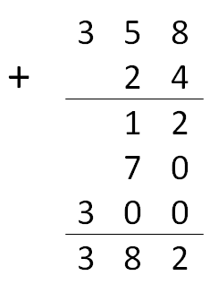 |  | 268 + 179 = 447  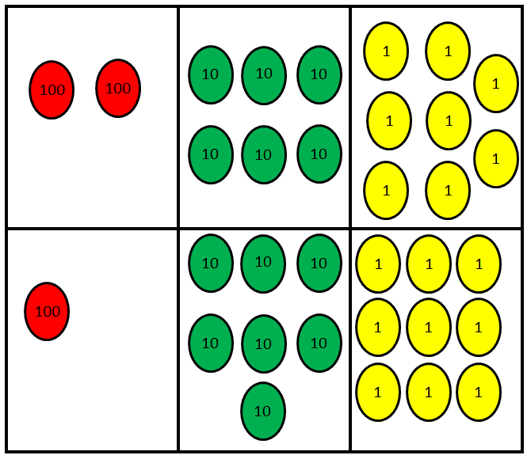
Exceeding children may begin to use the formal columnar method (using regrouping).  Addition of two numbers (up to three digits) using columnar addition  Formal column method | 487 + 256 = 743  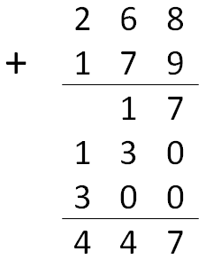 |  | 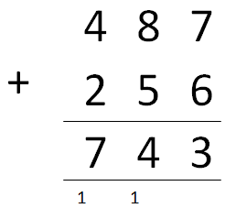

Year 4
Pupils should be taught to:
- add numbers with up to 4 digits using the formal written methods of columnar addition where appropriate
- estimate and use inverse operations to check answers to a calculation
- solve addition two-step problems in contexts, deciding which operations and methods to use and why
Add a multiple of 1000 or 100 to a 4-digit number 1800 + 700  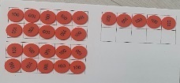  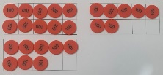 | 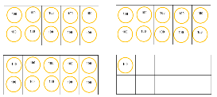  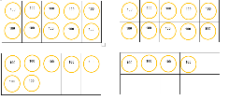  1700 + 1400 | 1800 + 700 1700 + 1400  200 500 1100 + 300
Calculate mentally  - rounding up/down and adjusting  - doubling  - adding near doubles  - using number bond knowledge |  | 1376 + 1598  1374 + 2 1374 + 1600  Also ensure children understand  even + even = even  Even + odd = odd  Odd + even = odd  Odd + odd = even
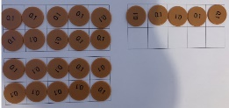  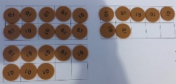  Add numbers to one decimal place 1.8 + 0.7 | 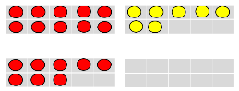  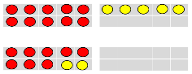  1.8 + 0.7 | 1.8 + 0.7  0.2 0.5
Add numbers using columnar where necessary  (using regrouping) |  | 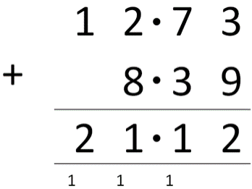  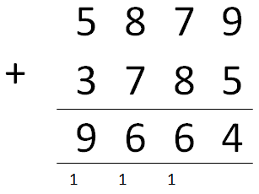

Year 5
Pupils should be taught to:
- add whole numbers with more than 4 digits, including using formal written methods (columnar addition)
- add numbers mentally with increasingly large numbers
- solve addition and subtraction multi-step problems in contexts, deciding which operations and methods to use and why

Use of mental methods, where appropriate | Children should be taught to complete mental calculations by:  - rounding up/down and adjusting  - doubling  - adding near doubles  - using number bond knowledge  - adding without bridging 1, 10, 100 or 1000  Use mixed decimal and whole (9 + 1.9)  Used mixed decimal 1dp and 2dp (1.82 + 0.3, 1.5 + 0.07) | Examples  1445 + 2999  1445 + 3000 – 1  1299 + 1299  Double 1300 - 2  443 + 445  Near double 443 + 2  12.36 + 5.24  0.36 + 0.24 = 0.6  17 + 0.6 = 17.6  36.25 + 23.43  Add each place value column individually
Addition of two numbers (more than four digits) using columnar addition  Formal method | Formal method (using regrouping) with more than four digits  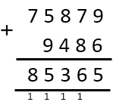  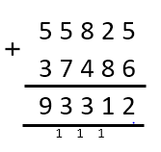 | 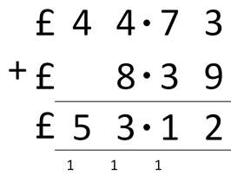  Use formal method to solve two-step problems in contexts.  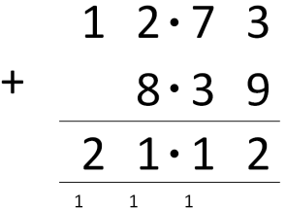
Year 6
Pupils should be taught to:
- perform mental calculations, using increasingly large numbers
- use their knowledge of the order of operations to carry out calculations involving the 4 operations
- solve addition multi-step problems in contexts, deciding which methods to use and why
- solve problems involving addition

Use of mental methods, where appropriate | Children should be taught to complete mental calculations by:  - rounding up/down and adjusting  - doubling  - adding near doubles  - using number bond knowledge  - adding without bridging 1, 10, 100 or 1000  Use mixed wholes  Use mixed whole and decimals  Use mixed decimals up to 3 dp | Examples  1745 + 2999  1745 + 3000 – 1  1399 + 1399  Double 1400 - 2  1343 + 1345  Near double 1343 + 2  12.36 + 5.24  0.36 + 0.24 = 0.6  17 + 0.6 = 17.6  36.25 + 23.43  Add each place value column individually
As Year 5, continue to use formal methods of addition, progressing to larger numbers, solving multi-step problems and applying methods to real life contexts. Continue calculating with decimals (including those with a different number of decimal places)
Apply both mental and formal methods to solve calculations | 6 + 7 × 8 = 62 because multiplication first then addition when there are no brackets as long as the symbol moves with the number  2780 – 910 + 1220 can be reordered to 2780 + 1220 – 910= 3090  Use rules of BIDMAS
SUBTRACTION

Year 3
Pupils should be taught to:
- subtract numbers mentally, including:
  - a three-digit number and 1s
  - a three-digit number and 10s
  - a three-digit number and 100s
- subtract numbers with up to 3 digits, using formal written methods of columnar addition and subtraction
- solve problems, including missing number problems, using number facts, place value, and more complex subtraction

 | Concrete |  |  | Pictorial |  |  | Abstract
Subtract HTO – O (using bonds leading to partitioning) | 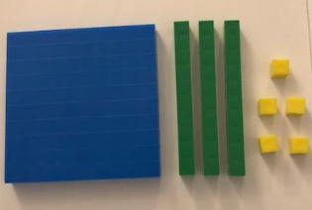  135 – 2 = 133 |  |  | 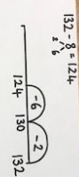 |  |  | 148 – 5 = 143  152 – 7 = 152 - 2 – 5 = 145  Also ensure children understand  even - even = even  Even - odd = odd  Odd - even = odd  Odd - odd = even
Subtract HTO – T (using bonds leading to partitioning) | 135 – 20 = 115 |  |  | 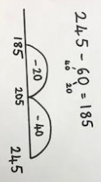 |  |  | 248 – 20 = 228  162 – 70 = 92  162 – 60 = 102  102 – 10 = 92
Subtract HTO – H (using bonds) | 635 – 400 = 235 |  |  | 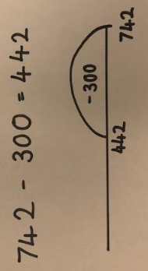 |  |  | 478 – 200 = 278
Subtract any TO – TO  Using partitioning | 72 – 26 = 46  Use dienes to model 72 – 20 – 2 – 4 = 46 |  |  | 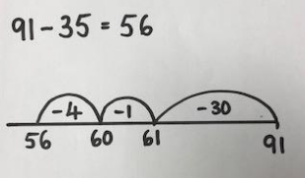 |  |  | 78 – 49 = 29  78 – 40 – 8 – 1 = 29
Children should also be taught to calculate the difference when two numbers are close in range | 114 - 102
Subtraction of two numbers, HTO – HTO  Using expanded method | 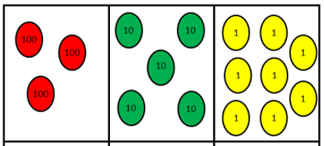  358 – 173 =  Show using place value counters (modelling exchange of ten 10s for one 100) |  | 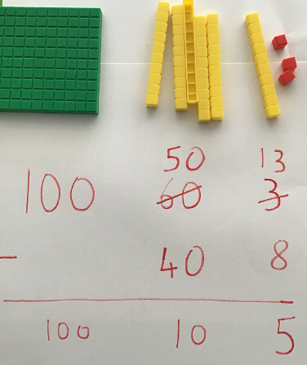 |  |  | 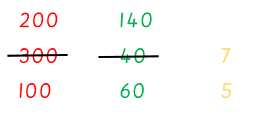  347 -165 =  .
Exceeding children may begin to use formal columnar method.  Subtraction of two numbers, HTO – HTO  Using formal method | 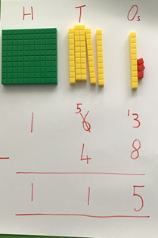 | 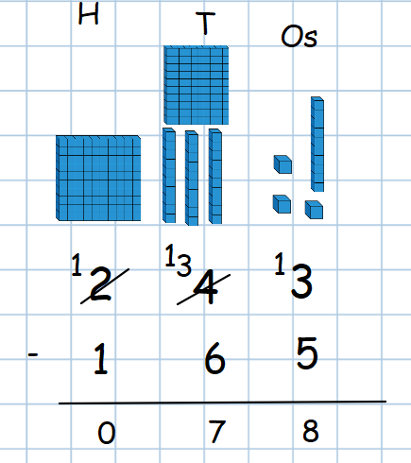 |  |  | 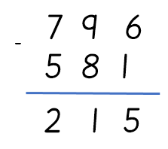  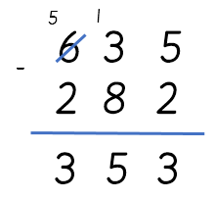

Year 4
Pupils should be taught to:
- subtract numbers with up to 4 digits using the formal written methods of columnar subtraction where appropriate
- estimate and use inverse operations to check answers to a calculation
- solve subtraction two-step problems in contexts, deciding which operations and methods to use and why

Subtraction of multiples 10/100/1000 | 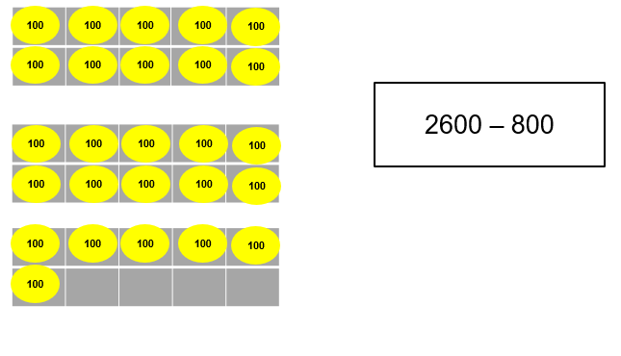 |  | 2600 – 800 or 2600 – 800 = 2600 – 1000 + 200  600 200
Use of mental methods, where appropriate | Children should be taught to complete mental calculations by:  - rounding up/down and adjusting  - counting up  - using number bond knowledge  - subtracting without bridging 1, 10, 100 or 1000 |  | Example  532 – 199  532 – 200 + 1  308 – 289 = 19 (found by 1 + 10 + 8)  289 + 1 + 10 + 8 = 308  507 – 57  507 – 7 – 50  5839 – 1725  Subtract each column individually using place value knowledge  Also ensure children understand  even - even = even  Even - odd = odd  Odd - even = odd  Odd - odd = even
Subtract a pair of numbers to 1 dp | 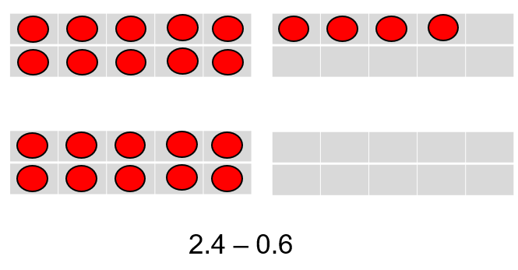 |  | 2.4 – 0.6  0.4 0.2
Children should also be taught to calculate the difference when two numbers are close in range | 114 – 102=12  4  8  114  110  102
Learners should have a solid understanding of expanded method of subtraction (Year 3)  Subtraction of two numbers (up to four digits) using columnar subtraction  Formal method | 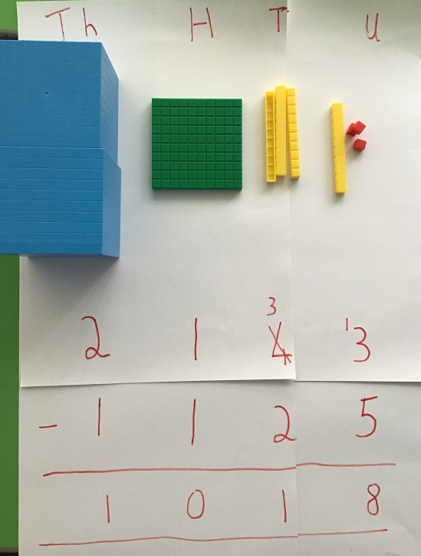 | 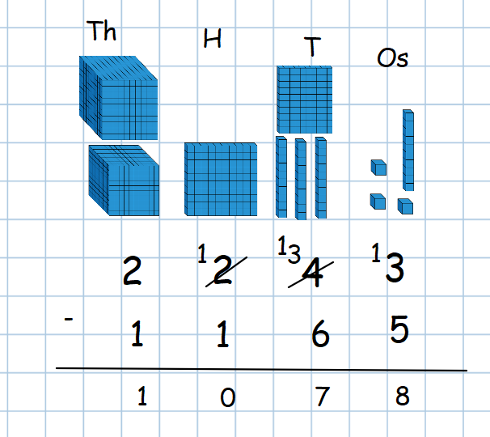 | 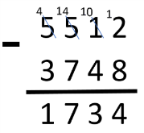  Formal method (using exchanging) with numbers up to four digits.  Leading to using columnar method to solve problems using decimals up to 2 places.  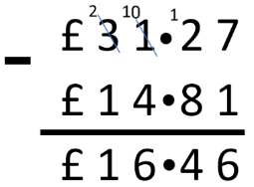

Year 5
Pupils should be taught to:
- subtract whole numbers with more than 4 digits, including using formal written methods (columnar subtraction)
- subtract numbers mentally with increasingly large numbers
- solve subtraction multi-step problems in contexts, deciding which methods to use and why

Use of mental methods, where appropriate | Children should be taught to complete mental calculations by:  - rounding up/down and adjusting  - counting up  - using number bond knowledge  - subtracting without bridging 1, 10, 100 or 1000 (including decimals)  Use mixed decimal and whole (9 – 1.9)  Used mixed decimal 1dp and 2dp (1.52 – 0.3, 1.5 – 0.07) |  | Examples  4532 – 1999  4532 – 2000 + 1  £10 - £7.71 = £2.29  £7.71 + 29p = £8 + £2 = £10  2507 – 57  2507 – 7 – 50  75839 – 41725  8.67 – 0.6 = 8.07  Subtract each column individually using place value knowledge
Subtraction of two numbers (more than four digits) using columnar subtraction  Formal method | 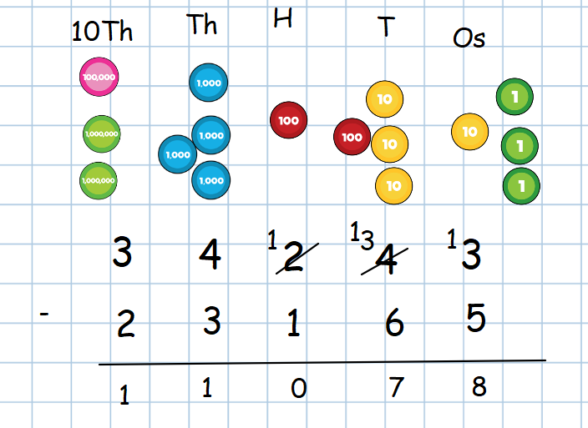 | Formal method (using exchanging) with numbers up to five digits.  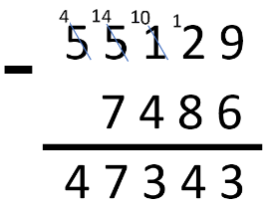  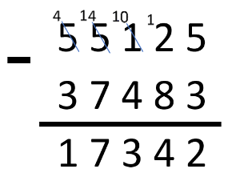 | Using formal method to solve two-step problems in contexts, including decimals.  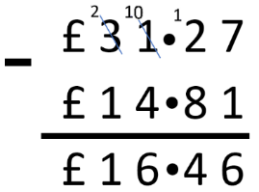

Year 6
Pupils should be taught to:
- perform mental calculations, including with increasingly large numbers
- use their knowledge of the order of operations to carry out calculations involving the 4 operations
- solve subtraction multi-step problems in contexts, deciding which methods to use and why
- solve problems using subtraction

Use of mental methods, where appropriate | Children should be taught to complete mental calculations by:  - rounding up/down and adjusting  - counting up  - using number bond knowledge  - subtracting without bridging 1, 10, 100 or 1000 (including decimals)  Use mixed wholes  Use mixed whole and decimals  Use mixed decimals up to 3 dp | Examples  74532 – 19996  74532 – 20000 + 4  £10 - £7.71 = £2.29  £7.71 + 29p = £8 + £2 = £10  308 – 289 = 19 (found by 1 + 10 + 8)  289 + 1 + 10 + 8 = 308  2507 – 57  2507 – 7 – 50  75839 – 41725  7.57 – 0.07 = 7.5  6.982 – 0.08 = 6.902  Subtract each column individually using place value knowledge
As Year 5, continue to use formal methods of subtraction, progressing to larger numbers, solving multi-step problems and applying methods to real life contexts. Continue calculating with decimals (including those with a different number of decimal places)
Apply both mental and formal methods to solve calculations | See addition section for BIDMAS rules.

MULTIPLICATION

Year 3
Pupils should be taught to:
- recall and use multiplication facts for the 3, 4 and 8 multiplication tables
- write and calculate mathematical statements for multiplication using the multiplication tables that they know, including for two-digit numbers times one-digit numbers, using mental and progressing to formal written methods
- solve problems, including missing number problems, involving multiplication, including positive integer scaling problems and correspondence problems in which n objects are connected to m objects

 | Concrete | Pictorial | Abstract
Count in 4s, 8s, 50s and 100s | 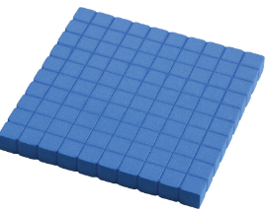  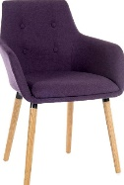  Count objects in groups of 4s, 8s, 50s and 100s. | 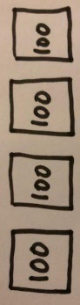  Use pictures of objects in groups of 4, 8, 50 and 100. | 12, 16, 20, , 28, , 36
Recall and use facts for 3, 4 and 8  Children to learn using anchor facts | Count objects in groups (3, 4 and 8)  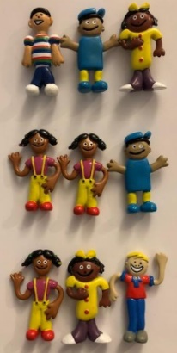  e.g. use match sticks to make triangles and count in 3s. | Use images to show facts of 3, 4 and 8  24  3 3 3 3 3 3 3 3  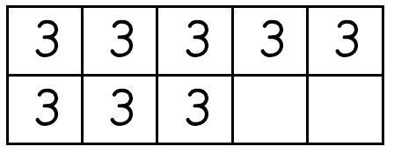  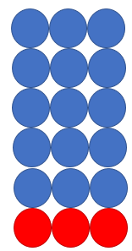 | 3 X 4 =  use facts to show inverse  4 X 3 = 12  12 ÷ 4 = 3  12 ÷ 3 = 4  3 is a factor of 12  4 is a factor of 12  12 is a multiple of 3 and 4  Continue to other facts  e.g. 6 x 2 =12  12 x 1 = 12  Other facts :  Even x Even = Even  Odd x Even = Even (It doesn’t matter how many groups of even you have, it will aways be even.  Even x Odd = Even  Odd x Odd = Odd
Multiply TO X O (O only 2, 3, 4, 5, 8) | 13 X 4 =  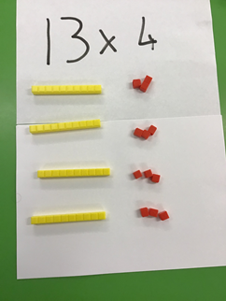  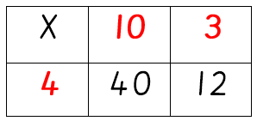  40 + 12 = 52 | 24 X 4 =  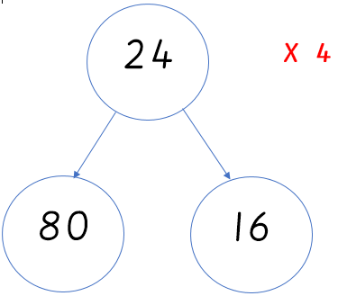 | 24 X 4 =  2 4  x 4  - 6 (4x4)  8 0 (4x20)  9 6

Year 4
Pupils should be taught to:
- recall multiplication facts for multiplication tables up to 12 × 12
- use place value, known and derived facts to multiply mentally, including: multiplying by 0 and 1; multiplying together 3 numbers
- recognise and use factor pairs and commutativity in mental calculations
- multiply two-digit and three-digit numbers by a one-digit number using formal written layout
- solve problems involving multiplying and adding, including using the distributive law to multiply two-digit numbers by 1 digit, integer scaling problems and harder correspondence problems such as n objects are connected to m objects

 | Concrete | Pictorial | Abstract
Count in 25s, 250s and 1000s | Count objects in 25s, 250s and 1000s.  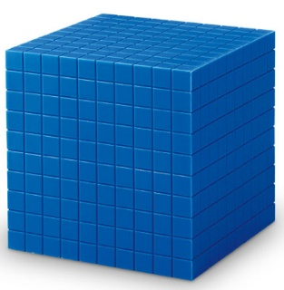 | 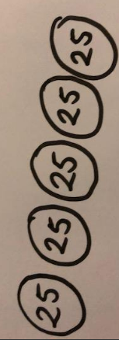  Use pictures of objects/values to count in 25s, 250s and 1000s. | 25, 50, 75, , 125,
Recall and use facts for 7, 9, 11 and 12  Children to learn using anchor facts | Count objects in groups (7, 9, 11 and 12)  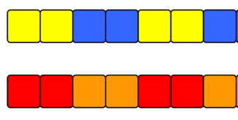 | Use images to show facts of 7, 9, 11 and 12  63  7 7 7 7 7 7 7 7 7  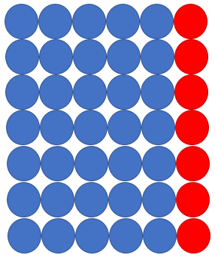  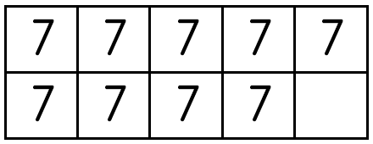 | 7 X 6 =  use facts to show inverse  6 X 7 = 42  42 ÷ 6 = 7  42 ÷ 7 = 6  6 is a factor of 42  7 is a factor of 42  42 is a multiple of 6 and 7  Continue with other facts  e.g. 14x3 =42  28 x 1.5 = 42  12 x 3.5 =42  Other facts :  Even x Even = Even  Odd x Even = Even (It doesn’t matter how many groups of even you have, it will aways be even.  Even x Odd = Even  Odd x Odd = Odd
Multiply a given number by 10 and 100 | This objective is covered in the topic of fractions.
Multiply TO X O (grid method)  All methods to be taught alongside each other. | 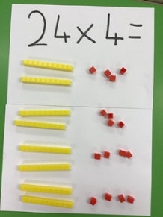  Use concrete and pictorial to show how we can partition:  24x4=96  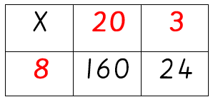  Grid method to be used to focus on different ways to partition numbers and to assess effectiveness of a method. | 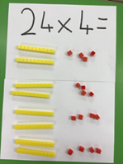  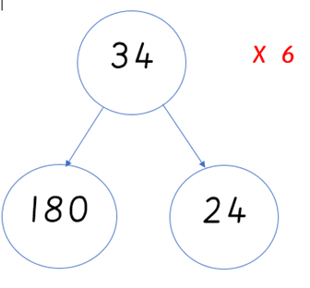  24x6=96 (shown on IWB )  34x6=204 | - 4  x 7  - 8 (7x4)  7 0 (7 x10)  9 8
Multiply HTO X O (grid method)  All methods to be taught alongside each other. | 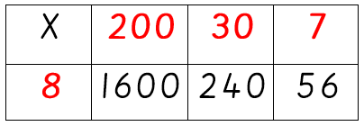  Grid method to be used to focus on different ways to partition numbers and to assess effectiveness of a method. | 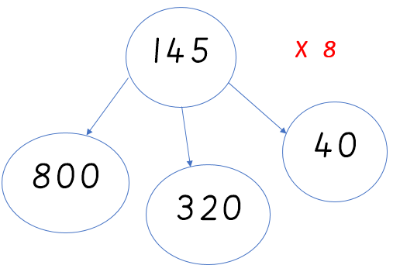 | 1 2 4  X 6  2 4 (6x4)  1 2 0 (6 x 20)  6 0 0 (6x100)  7 4 4

Year 5
Pupils should be taught to:
- multiply numbers up to 4 digits by a one- or two-digit number using a formal written method, including long multiplication for two-digit numbers
- multiply numbers mentally, drawing upon known facts
- multiply whole numbers and those involving decimals by 10, 100 and 1,000
- solve problems involving multiplication, including using their knowledge of factors and multiples, squares and cubes
- solve problems involving multiplication including understanding the meaning of the equals sign

Before any formal methods of multiplication are taught, the following objectives should be covered using BMS resources;
- Identify multiples and factors
- Prime, square, cube and common
- Multiplying by 10, 100 and 1000
- Know and apply facts (6 X 7 = 42 used to calculate 0.6 X 0.7 = 0.42)

Multiply 4dgt X 1dgt  Recap previous methods taught, expected children should be introduced to the formal method in spring/summer term of Year 5. | 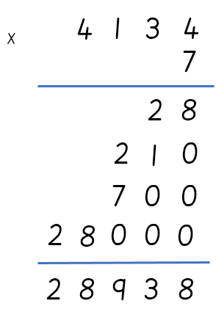 |  | 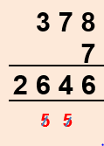  x  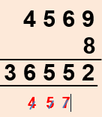  x
Multiply 2dgt X 2dgt  (using regrouping) | 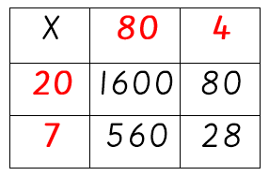  Used to model place value to ensure secure understanding when using expanded method | 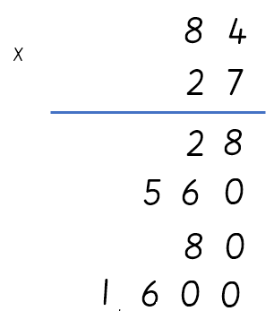  2 2 6 8  1 1 |  | 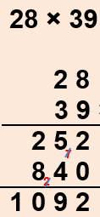  x
Multiply up to 4dgt X 2dgt | 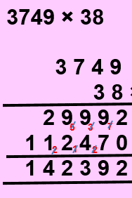  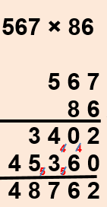  x  x

Year 6
Pupils should be taught to:
- multiply multi-digit numbers up to 4 digits by a two-digit whole number using the formal written method of long multiplication
- perform mental calculations, including with mixed operations and large numbers
- use their knowledge of the order of operations to carry out calculations involving the 4 operations
- solve problems involving multiplication

Multiply 4dgt X 2dgt | 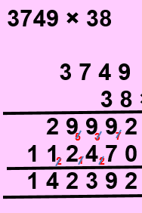  x
Multiply 1dgt (up to two decimal places) X whole number  Use this method to solve problems involving various units of measure (e.g. money, capacity etc.) | 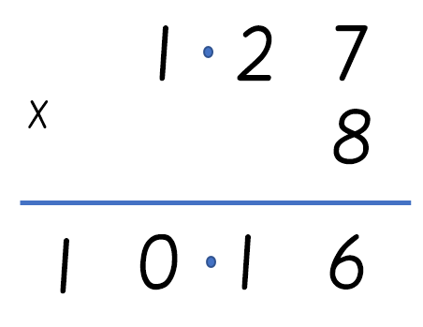  2  5

DIVISION
Year 3
Pupils should be taught to:
- recall and use division facts for the 3, 4 and 8 multiplication tables
- write and calculate mathematical statements for division using the multiplication tables that they know, including for two-digit numbers times one-digit numbers, using mental and progressing to formal written methods
- solve problems, including missing number problems, involving division, including positive integer scaling problems and correspondence problems in which n objects are connected to m objects

 | Concrete | Pictorial | Abstract
Recall and use facts for 3, 4 and 8  Children to learn using anchor facts | Count objects in groups (3, 4 and 8) | Use images to show facts of 3, 4 and 8  24  3 3 3 3 3 3 3 3 | 3 X 4 =  use facts to show inverse  4 X 3 = 12  12 ÷ 4 = 3  12 ÷ 3 = 4  3 is a factor of 12  4 is a factor of 12  12 is a multiple of 3 and 4  Continue to other facts e.g. 2 x 6 =12  1x12 = 12 0.5 x 24 =12  12 ÷ 6 = 2
Division TO ÷ O (2, 3, 4, 5, 8, 10)  Including remainders | 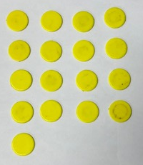  17 ÷ 4 = 4 r 1 | 65÷8=8r1  65  8 8 8 8 8 8 8 8 1  64 1  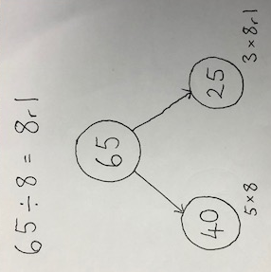 | 17 ÷ 4 = 4 r  ÷ 5 = 6 r 2

Year 4
Pupils should be taught to:
- recall division facts for multiplication tables up to 12 × 12
- use place value, known and derived facts to divide mentally
- recognise and use factor pairs and commutativity in mental calculations
- multiply two-digit and three-digit numbers by a one-digit number using formal written layout
- solve problems involving multiplying and adding, including using the distributive law to multiply two-digit numbers by 1 digit, integer scaling problems and harder correspondence problems such as n objects are connected to m objects

 | Concrete | Pictorial | Abstract
Recall and use facts for all numbers 2-12  Children to learn using anchor facts | Count objects in groups (7, 9, 11 and 12) | Use images to show facts of 7, 9, 11 and 12  63  7 7 7 7 7 7 7 7 7 | 7 X 6 =  use facts to show inverse  6 X 7 = 42  42 ÷ 6 = 7  42 ÷ 7 = 6  6 is a factor of 42  7 is a factor of 42  42 is a multiple of 6 and 7  Continue to other facts e.g.  14x3=42  42 ÷ 3=14  42÷ 12= 3.5
Division TO ÷ O  Including remainders | 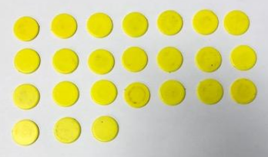  24 ÷ 7 = 3 r 3 | 74 ÷6=12r2  74  6 6 6 6 6 6 6 6 6 6 6 6 2  72 2  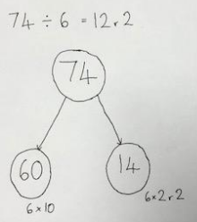 | 43 ÷ 7 = 6 r  ÷ 9 = 5 r 2

Year 5
Pupils should be taught to:
- divide numbers mentally, drawing upon known facts
- divide numbers up to 4 digits by a one-digit number using the formal written method of short division and interpret remainders appropriately for the context
- divide whole numbers and those involving decimals by 10, 100 and 1,000
- solve problems involving division, including using their knowledge of factors and multiples, squares and cubes
- solve problems involving addition, subtraction, multiplication and division and a combination of these, including understanding the meaning of the equals sign
- solve problems involving division, including scaling by simple fractions and problems involving simple rates

Before any formal methods of division are taught, the following objectives should be covered using BMS resources;
- Identify multiples and factors
- Prime, square, cube and common
- Dividing by 10, 100 and 1000
- Know and apply facts (42 ÷ 7 = 6 used to calculate 0.42 ÷ 0.7 = 0.6)
Divide 3dgt ÷ 1dgt | 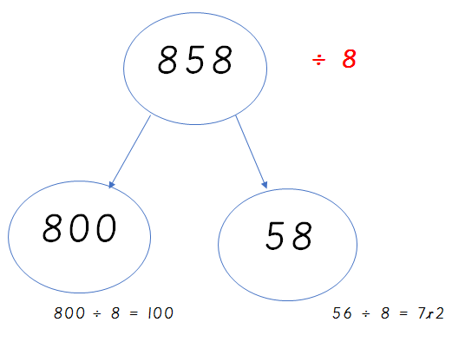  858 ÷ 8 = 107 r 2 | 138 ÷ 6 = 23  Do this with concrete and visual materials.  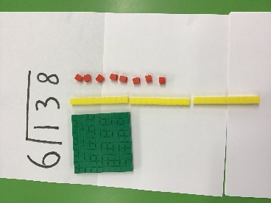  316 ÷ 5 = 63 r 1  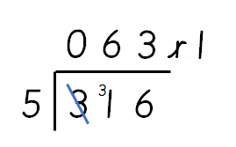
Divide 4dgt ÷ 1dgt | 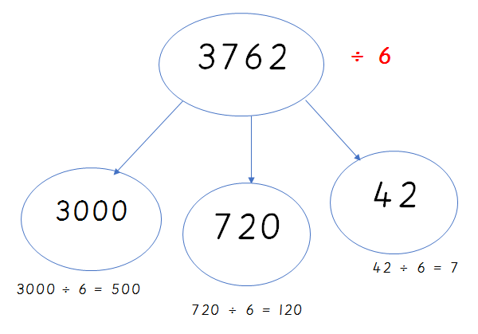  3762 ÷ 6 = 627 | 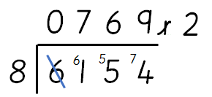  6154 ÷ 8 = 769 r 2

Year 6
Pupils should be taught to:
- divide numbers up to 4 digits by a two-digit whole number using the formal written method of long division, and interpret remainders as whole number remainders, fractions, or by rounding, as appropriate for the context
- divide numbers up to 4 digits by a two-digit number using the formal written method of short division where appropriate, interpreting remainders according to the context
- perform mental calculations, including with mixed operations and large numbers
- use their knowledge of the order of operations to carry out calculations involving the 4 operations
- solve problems involving division

Division of 3dgt ÷ 2dgt | 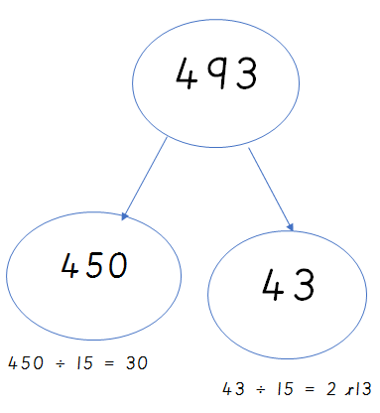  493 ÷ 15 = 32 r 13 | 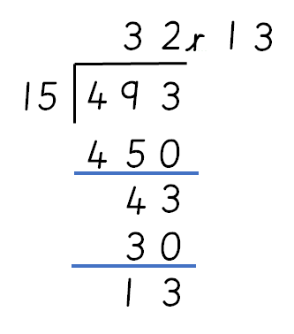  493 ÷ 15 = 32 r 13
Division of 4dgt ÷ 2dgt | 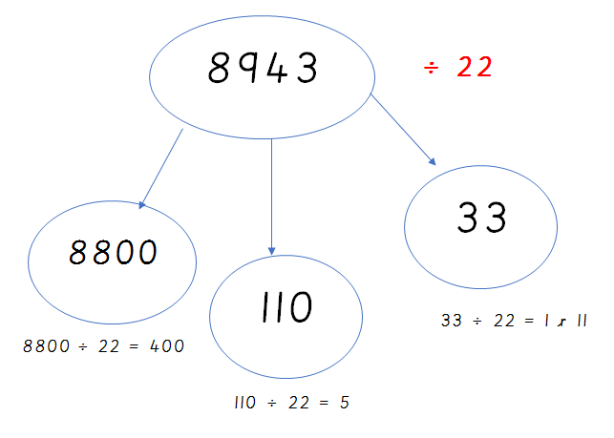  8943 ÷ 22 = 406 r 11 | 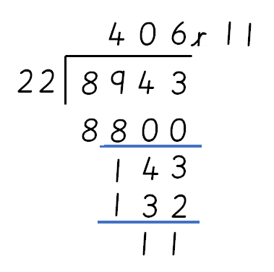  8943 ÷ 22 = 406 r 11

