Great Moor Junior

School

Knowledge Organiser Year 4

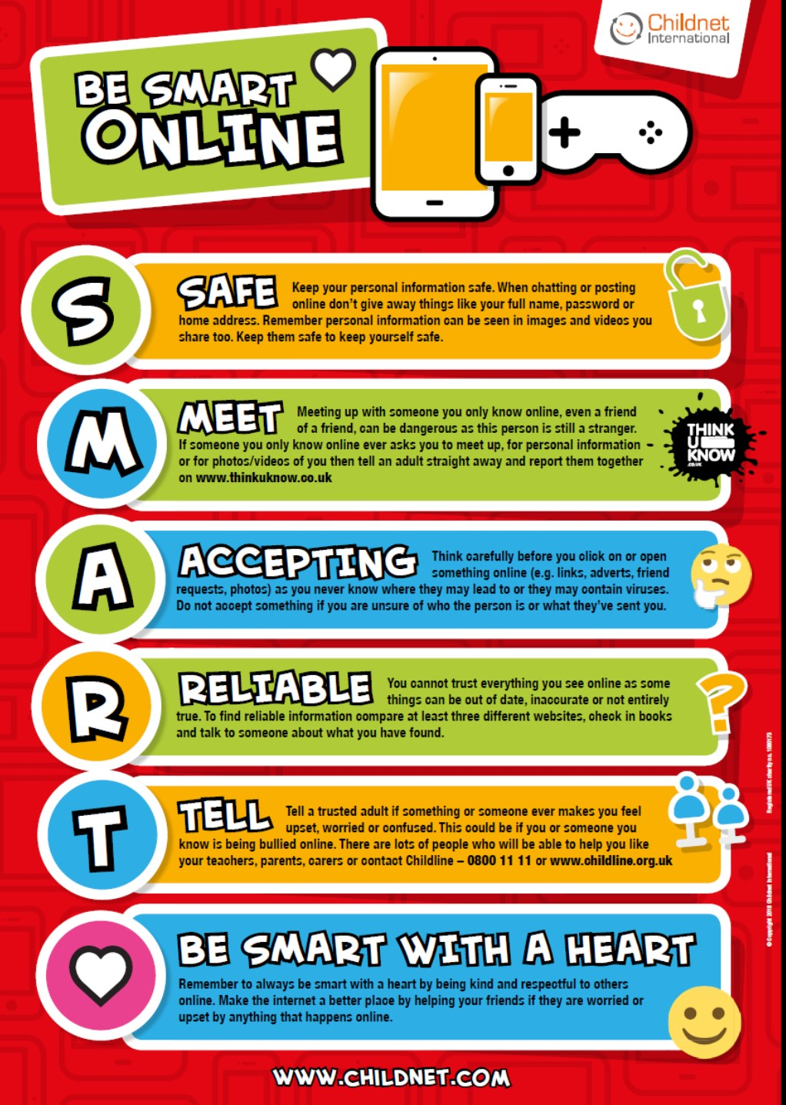

# Year 4 Autumn 1: Creating Wikis

**Computing** Focus: Digital Literacy (IT and E-safety) and

Using technology

**What you should know from Year 3:** Searching with keywords. Using Word to create simple documents, Use iMovie for filming and photos. Used a website for uploading work. Used a mouse, use a keyboard, copy and paste

**In this unit** we use the internet to search the World Wide web safely and develop the use of wikis and word processing skills to communicate information

**Key Knowledge, vocabulary and skills**

|  |  |
| --- | --- |
| Search the World Wide web through the Internet using key words and child friendly websites :  Kiddle <https://www.kiddle.co/>  Swiggle <https://swiggle.org.uk/>  DK Findout  <https://www.dkfindout.com/uk/> | |
| **The**  **Internet** | An interconnected network made of computers connected to each other around the world. |
| **Search** | Search technology is any tool that can look for websites you want to find. |
| **web browser** | Finds and displays pages from the World Wide Web, Examples of browsers are: Safari, Google Chrome, Internet Explorer, Edge etc. |
| **Wiki** | A wiki which is a website that allows users to contribute and modify its content individually and collaboratively. It is named wiki after a Hawaiian word meaning "quick." The most famous wiki is Wikipedia. |

## Online safety / E-safety

**Remind about BE SMART rules**

**Focus on Privacy and security** ways to improve your privacy and security when online

# Year 4 Autumn 2: Programming with MSW Logo using Repetition

**Computing** Focus: Computer Science

**What they should know from Year 2:** sequence, algorithm, bug, debugging **In this unit** we learn about creating algorithms and using Logo to create programs to implement them

**Key Knowledge, vocabulary and skills**

|  |  |
| --- | --- |
| **Vocabulary and skills** | **Examples in Logo** |
| **Algorithm**  An algorithm is a precise set of ordered instructions, which can be turned into code | Here is an example of an algorithm: Right turn 90 degrees, forward 10 steps, right turn 90 degrees (code below) |
| **Turtle** Home position  (centre of screen for Turtle) |  |
| **Debugging** Finding and correcting errors in your code. | Commands typed incorrectly  e.g. rt90; no space between rt and 90 |
| **Sequence** is a specific order for a set of instructions. | A sequence in Logo.  **RT 90 FD 10 RT 90 FD 10** |
| **Repetition** a sequence that is repeated a number of times | ⭐⭐⭐🌙🌙⭐⭐⭐🌙🌙 here the sequence is repeated twice |
| **Repetition in an algorithm**  Repeat 3 times: Draw ✳♡  Draw ♡ | output is ✳♡♡✳♡♡✳♡♡ |
| **Count controlled loops** (**Repetition)** These repeat the loop a number of times | The number after **repeat** is the number of times to repeat the code. The code to be repeated is in square brackets. e.g. **repeat 4 [FD 100 LT 90]** |
| **Decomposition** breaking down a task into smaller, more-manageable parts. | In Logo breaking the code sequence into chunks or snippets |
| **Procedure** is a code snippet that is given a name and can be reused in programming. | When creating a procedure in Logo, the word ‘**TO**’ is typed, followed by the procedure name, e.g. **TO SQUARE**. |

## Online safety / E-safety

**Focus on Online Bullying:** (linked to anti-bullying week) To know about different media in which you can be unkind. Bullying online is the use of technology to upset, threaten, embarrass or target another person regularly.

# Spring 1: Investigating data using data logging

**Computing** Focus: Collecting and presenting data

[**What**](https://docs.google.com/document/u/0/d/14dAWr1pAQJeejYA_xUGhwebMG5SPkvzKIur-0YQBrOQ/edit)[**they**](https://docs.google.com/document/u/0/d/14dAWr1pAQJeejYA_xUGhwebMG5SPkvzKIur-0YQBrOQ/edit)[**should**](https://docs.google.com/document/u/0/d/14dAWr1pAQJeejYA_xUGhwebMG5SPkvzKIur-0YQBrOQ/edit)[**know**](https://docs.google.com/document/u/0/d/14dAWr1pAQJeejYA_xUGhwebMG5SPkvzKIur-0YQBrOQ/edit)[**from**](https://docs.google.com/document/u/0/d/14dAWr1pAQJeejYA_xUGhwebMG5SPkvzKIur-0YQBrOQ/edit)[**Year**](https://docs.google.com/document/u/0/d/14dAWr1pAQJeejYA_xUGhwebMG5SPkvzKIur-0YQBrOQ/edit)[**3**](https://docs.google.com/document/u/0/d/14dAWr1pAQJeejYA_xUGhwebMG5SPkvzKIur-0YQBrOQ/edit)**:**data and information, collected and

presented data as a bar chart, inputs, outputs

**In this unit** we learn about collecting and presenting data

**Key Knowledge, vocabulary and skills**

|  |  |
| --- | --- |
| **data** It is a collection of numbers, words and symbols gathered by observation, questioning or measurement e.g. yes, no, 5, 7. cheese etc. , measurements, observations or just descriptions of  E.g. **the values** for health: temperature, heart rate; sport: number of runs; weather:  rainfall, wind speed etc. | |
| **information** is where data is presented in graphs, sentences etc. so that it makes sense and tells the reader something about the data. Data = 17 can become “The temperature is 17 degrees C .” | |
| |  |  |  |  | | --- | --- | --- | --- | | Weather |  |  |  | | Day | Summary | Temperature (°C) | Rainfall (mm) | | Sunday | Sunny | 21 | 0 | | Monday | Partly cloudy | 17 | 0 | | Tuesday | Overcast | 16 | 2 | | Wednesday | Overcast | 15 | 1 |   **data set data attribute data value**  The entire table is a **data set.**  The headings of each column is the **data attribute.**  The answers in the columns are the **data values** . | |
| **data logger** | A digital device that can collect data from sensors over time and store it. Data loggers can collect data about brightness of light, temperature, and loudness of sound etc. |
| **data point** | The moment data is collected by a sensor/data logger. Each moment is datum (singular of data). |

## Online safety / E-safety

**Safer Internet day**. **Focus on online reputation** to know that some information about anyone online could have been created, copied or shared by others.

**Spring 2: Programming games in Scratch using Repetition**

**Computing** Focus: Computer Science

**What they should know from Year 3** [**Autumn**](https://docs.google.com/document/d/14dAWr1pAQJeejYA_xUGhwebMG5SPkvzKIur-0YQBrOQ/edit#bookmark=id.g2f384invsr1)[**2**](https://docs.google.com/document/d/14dAWr1pAQJeejYA_xUGhwebMG5SPkvzKIur-0YQBrOQ/edit#bookmark=id.g2f384invsr1)**,** [**Summer**](https://docs.google.com/document/d/14dAWr1pAQJeejYA_xUGhwebMG5SPkvzKIur-0YQBrOQ/edit#bookmark=id.njak0acfllp8)[**1**](https://docs.google.com/document/d/14dAWr1pAQJeejYA_xUGhwebMG5SPkvzKIur-0YQBrOQ/edit#bookmark=id.njak0acfllp8) **and Year 4:**

sequence, algorithm, bug, debugging, loops, count controlled loops

**In this unit** we read and use count controlled loops and infinite loops in Scratch

**Key Knowledge, vocabulary and skills**

|  |  |
| --- | --- |
|  | Examples in Scratch |
| **Algorithm**  An algorithm is a precise set of ordered instructions, which can be turned into code | When the user clicks on the green flag, the sprite moves by 10 steps from its actual location. The code will be |
| **Sequence** is a specific order for a set of instructions. | The above code is in a specific order to be run through when the program is executed. |
| **Execute**  Makes the program run. | Using any of these event blocks will start a program |
| **Count controlled loops**  (**Repetition)**  These repeat the loop a number of times.  **Forever loop (Repetition)** These repeat the loop forever. |  |
| **Wait** blocks are used in many [projects](https://en.scratch-wiki.info/wiki/Project). A common use is with animation  **Hide** block  **Show** block |  |

**Online safety / E-safety Focus on Self-Image and Identity:**

# Summer 1: Photo Editing

**Computing** Focus: Multimedia

**What they should know from Year 3** to have used a camera before.

**In this unit** you will learn how to use a camera and photo editing software

**Key Knowledge, vocabulary and skills**

|  |  |
| --- | --- |
| **Main features of image editor: paint.net** |  |
| **Cropping** | Remove the outer layers of a picture is called cropping |
| **image effects to use** |  |
| **some tools to use:**  **clone stamp, recolor, magic wand** |  |

**Online safety / E-safety**

**Focus on Health Well-being and lifestyle**: Looking at the effects of using technology, especially online and computer games on our moods and feelings

# Summer 2: The Internet and Networks

**Computing** Focus: Networks

**What they should know from Year 3:** local networks

**In this unit** we will understand more about networks and how the Internet is a network; where it is; and how it relates to web pages.

**Key Knowledge, vocabulary and skills**

|  |  |
| --- | --- |
| **A local network connected by a router to other networks** |  |
| **The global network that forms the Internet (physically connected) and linked by cabling under the sea** |  |
| **web browser** | It lets you look at web pages (pages created and held on computers) and then found by searching the Internet. Examples of web browsers: Chrome, Safari, Edge, Firefox |
| **domains and websites:** | domain website address that ends **.gov** is a government website domain website address that ends **.sch.uk** is a school or college domain website address that ends **.fr** is a website from France domain website address that ends **.com** is a company |

|  |  |
| --- | --- |
| **Ownership of content online** | In most cases, copyright of any material is owned by the creator of that material. |
| **Creating content online** | Some websites enable you to create content e.g. Scratch, Chrome Music Lab and YouTube .  But others e.g BBC Newsround, only lets you view or listen to content. |

(all images from NCCE plans)

## Online safety / E-safety

**Focus on Copyright and ownership** To begin to find out about what you can and can’t reuse from the internet because of who owns the content.