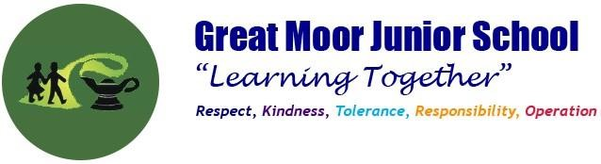

**PE at Great Moor Junior School**

What does a PE lesson look like in our school?

All our PE lessons are taught with the premise of ‘All the children moving/most of the time’, so they are very active and vigorous. Lessons contain clearly identified skills for the children to learn and there are lots of opportunities for children to develop good levels of fitness and to understand how exercise is an important part of a healthy life-style.

**How does P.E. work at Great Moor Junior School?**

Lessons are organised in half-termly blocks, timetabled so each class has two outdoor games lessons each week. Children will then do half-term blocks of indoor PE. This includes Gym, Dance and Swimming.

# Games

Every class participates in two games lessons each week which are held on our school’s outdoor artificial grass area. All lessons follow a similar format with a short warm-up, followed by activities to develop specific skills and then a game to put those skills to use.

Lessons are taught by two members of staff which enables one to provide specific support to pupils on an individual basis as needed whilst the other leads the lesson. It also enables our actual games to be small-sided (6/7 a side), with one member of staff concentrating on each game. We work hard to help children to develop their skills of both co-operation and competition. Children are in the same ‘teams’ for a half-termly block. We usually have an intra-class competition at the end of each unit with winning teams moving on to a competition with teams from other classes.

We teach games in half-termly blocks with all classes learning the same sport during the same half-term. Sports covered include:

Autumn Term – cricket, hockey, football

Spring Term – tag Rugby, netball (Y3/4)/basketball (Y5/6)

Summer Term – athletics, tennis.

Children are taught the importance of fair play, to develop a good understanding of rules, teamwork and tactics, to communicate effectively with teammates and to show respect towards opponents.

# Educational Gymnastics

Lessons all follow a simple format of warm-up, floor work and apparatus work. Children are encouraged to develop their fluency and co-ordination with a wide range of movements and to put them together in sequences. Thinking about how they move, improving coordination and timing, analysing and refining their own movements and developing self confidence are all important parts of lessons.



# Dance

Lessons are active and fun and cover dance from a range of genres and cultures. Children are taught to develop their co-ordination, expression, imagination and confidence through dance.

# Athletics

Children are involved in a wide range of running, jumping and throwing activities and work on developing and improving their techniques skills, strengths, speed, concentration, timing and performance. They are involved in measuring, recording and evaluating their performance and progress.

# Swimming

Lessons take place in a six-weekly block each year and are taught at Stockport Grammar School’s swimming pool which we walk to and from. Children are taught to develop their confidence and competence with swimming and to use a range of strokes. Children are taught how to be safe in and around water and how to manage a simple self-rescue.

Children enjoy PE and are engaged and challenged.

**What Assessment takes place?**

Teachers assess during lessons evaluating pupil progress as they learn develop and learn new skills. Notes are made on the medium term planning to keep a track of how children are doing.

# Half-termly assessments

Children are assessed throughout each half-term block by teachers. Teachers will use the assessment on GetSet4PE at the end of each unit of work to record the assessment. This is calculated over the year to give individual EMX assessment for Games, Dance and Gym.

# End of year assessment

Teachers use their half-termly assessments to inform their end of year assessment. Mr Gill and Miss Moston analyse this end of year data.