- Make sure presentation is always to the best of your abilities—take pride in your work!
Year 5: Always...

  - Underline with a ruler.
  - Choose the best writing implement for the
task e.g. tables to be drawn in pencil etc.
  - Stick any work in neatly.
  - Colour carefully.
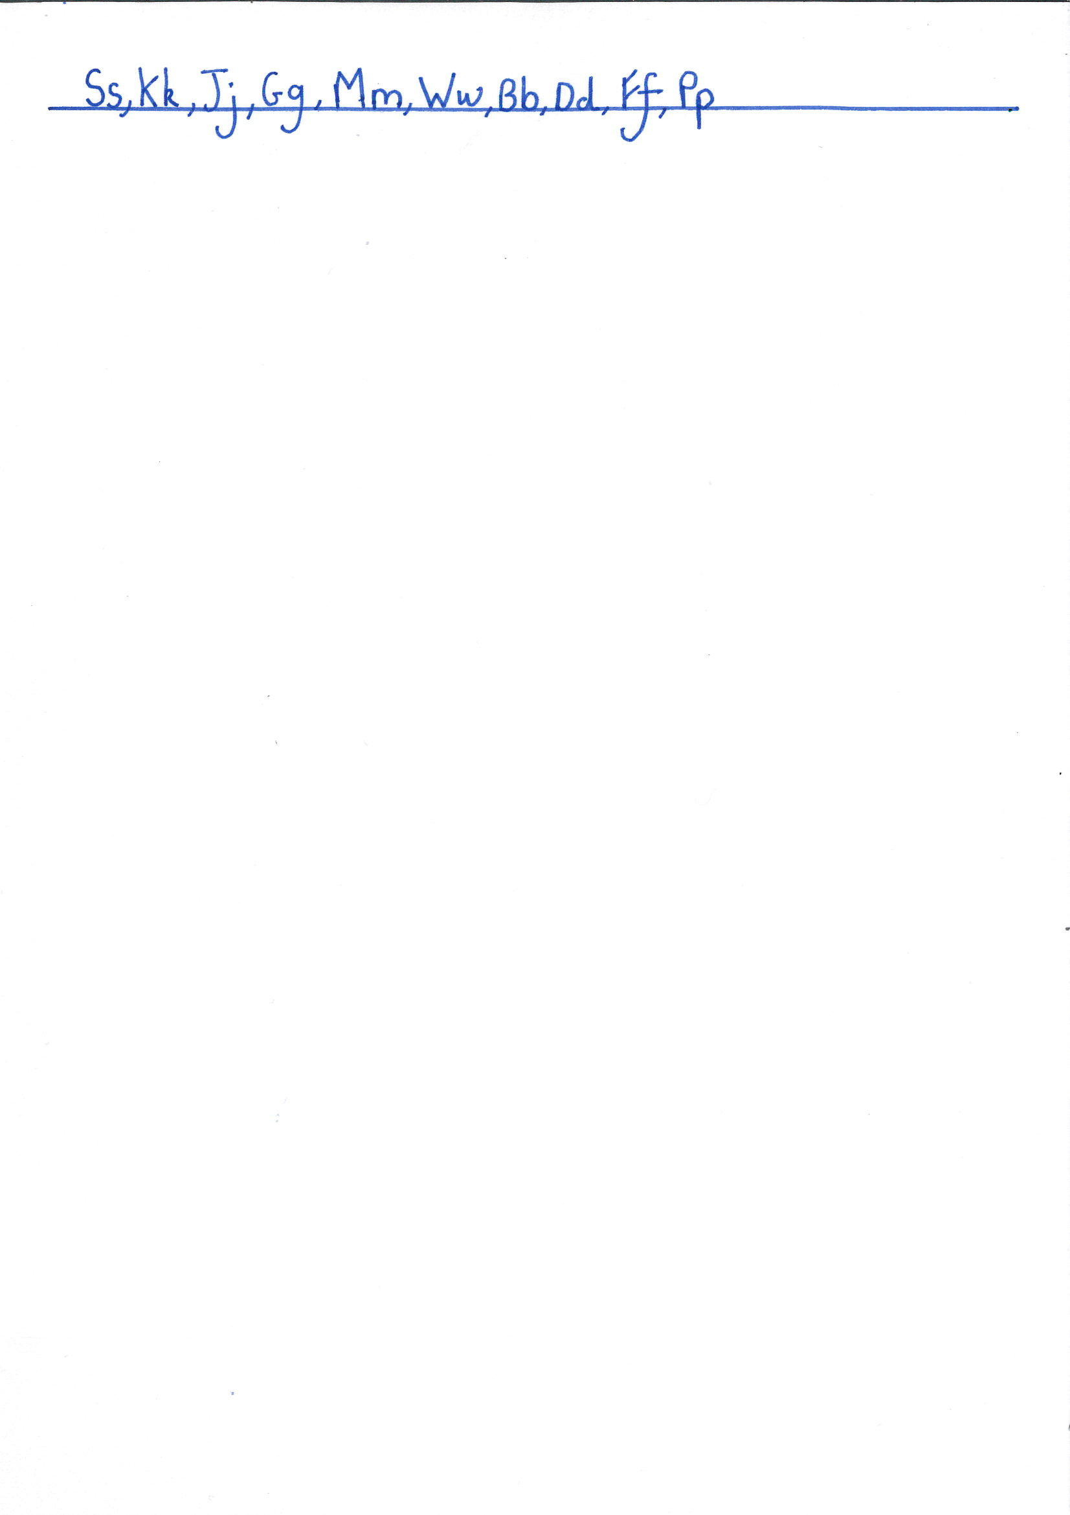
- Use joined, target handwriting for all work.
- Organise work appropriately with clear headings, titles, numbers or use paragraphs to help.
- Make sure you understand the L.O and show evidence that you can do it in your work—ask if you’re unsure!
- Take care with spellings—check if you are unsure.
- Read all work through and correct any mistakes before you hand it in.

