Free School Meals.
Would My Children in Key Stage 2 Be Eligible for Free School Meals?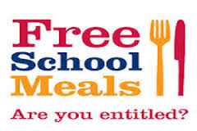
If you are in receipt of Income Support, Income-Based Job Seeker’s Allowance, Income related Employment Support Allowance or the Guarantee part of Pension Credit or if you have an annual income (as assessed by the HM Revenue and Customs) of less than £16,190 each year (but not Working Tax Credit) you will be eligible for Free School Meals.
Free School Meals could save you up to £380 per year for each child.
By applying for Free School Meals you could also trigger additional resources for your children’s school through the Pupil Premium. For every entitled child and whose parent has registered, the school will receive £900 to help children from lower income families. If you don’t want your child to have the free school meals they can continue with packed as normal – as long as you qualify and are registered – if you are making a claim for Housing Benefit or Council Tax Support the school will receive the additional funding.
How Do I Apply?
To claim Free School Meals you should fill in an online claim form.
You should also make a claim online if you are already receiving Housing Benefit and Council Tax Support and one of your children starts full-time nursery or school maintained by the Local Authority.
Access the Free School Meals online claim form HERE.
Once you have completed the online form and submitted it, it will be sent straight to the Free School Meals Team to be processed..

