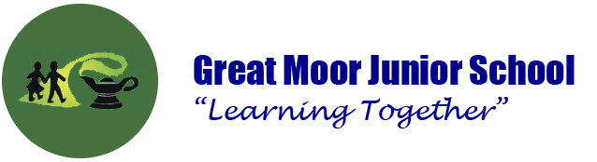

Remote Learning Protocols for Parents

All pupils are expected to participate in online lessons if there class have been asked to self-isolate. We ask that the following guidelines are adhered to during times of remote learning for our pupils.

Communication

You will be informed of online teaching schedules, arrangements and the work your child has been set through posts from your child’s class teacher on Google Classroom. You must be logged in as your child to access any information posted on Google Classroom.

Online provision

Three live lessons will take place each day at a time specified by the class teacher. Google Meet will be used for this session and it is accessible via Google Classroom.

The school’s Behaviour Policy will be applied as normal throughout any online learning

Participation in live sessions

Cameras must be turned on and children must be visible at all times for safeguarding reasons.

We ask that children join the lesson suitably dressed, please.

You do not need to sit with your child during the live session.

Please ensure that backgrounds are appropriate for all participants to see and all in the home are aware.

Access to live sessions will only be granted to pupils using their Great Moor Junior School Google account.

All online sessions will be delivered and supervised by a Great Moor Junior School member of staff.

No recording of live sessions is permitted.

Attendance and completion of assignments are monitored to ensure that no pupil falls behind and so alternative provision can be put in place if necessary.

Teachers will conduct phone calls home if pupils have not engaged in lessons to see if there is any way in which they can help.

Devices can be loaned to pupils to take part via the school office if necessary.

