https://parent-support.parentpaygroup.com/hc/en-gb/articles/15444655523985-ParentPay-Clubs-How-to-book-a-session

How to book sessions at Fun Club:

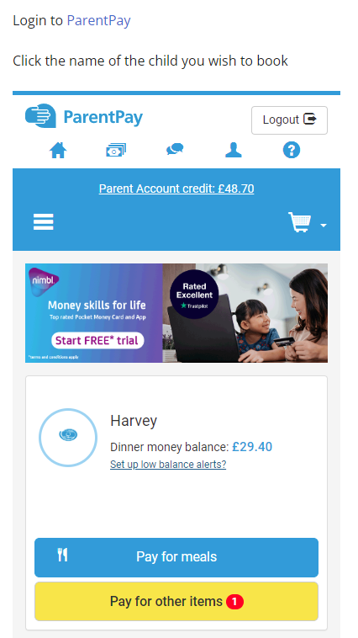
Step 1:

Step 2: On the menu, select ‘Clubs’.

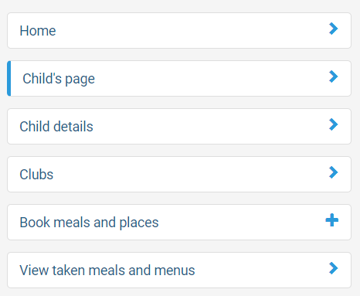

Step 3: Next, select ‘View Club’.

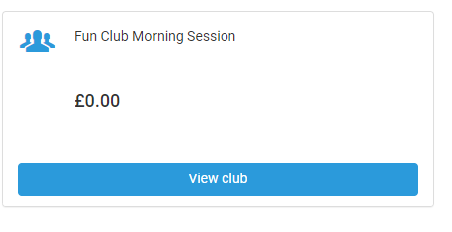

Step 4: Make your relevant bookings.

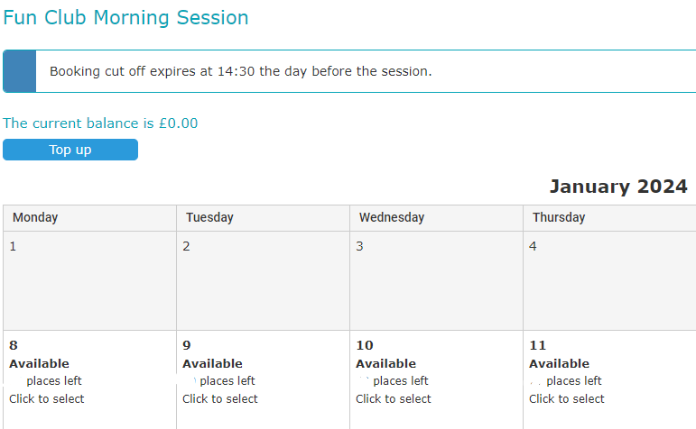

Step 5: Book selected sessions.

