https://parent-support.parentpaygroup.com/hc/en-gb/articles/4410744979473-How-to-make-meal-or-event-bookings#01FZGHG9Q7ANEY8DMXYG84760R

How to make meal or event bookings
The bookings option will be available in the left side menu (or in the menu drop down if using a mobile device).
Making bookings
- Go to www.parentpay.com and log in.
- Select the child to make bookings for [1].
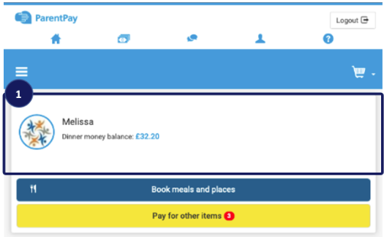
- From the menu [2] select Book meals and places > Make bookings [3].
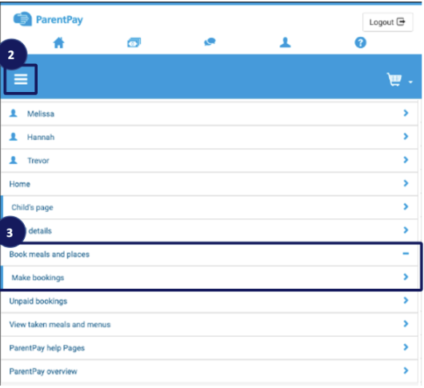
- Select the Event that you wish to make a booking for [4] and If required choose a week. Then select Make or view bookings [5].
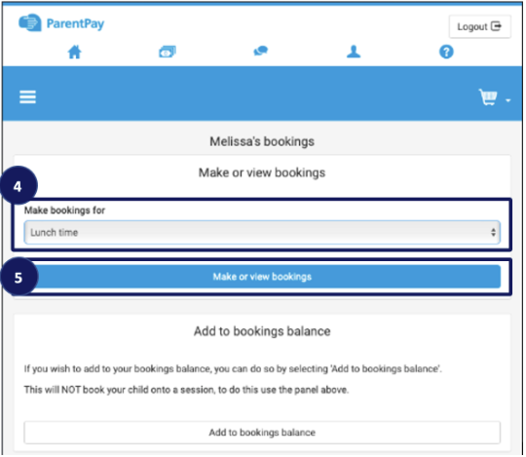
- A booking screen will be presented:
NOTE Several possible bookings screens are available based on the options chosen by the child's school setup. Each of these options are displayed below:
GMJS - OPTION 4: Book a meal or event with no menu to view. Use the Next week button to make further bookings.
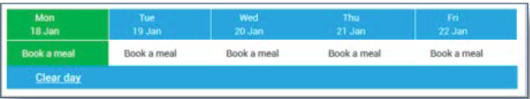
- Make all desired bookings.
- A summary will be displayed at the bottom of the page with any previous unpaid bookings shown in red. 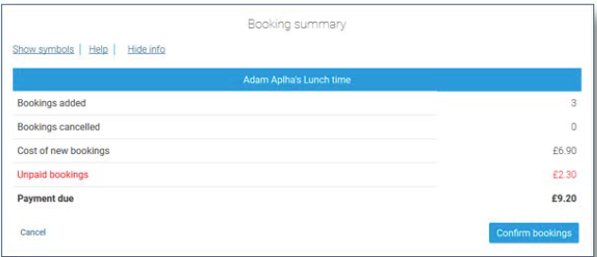WARNING: Any bookings must be confirmed and (if required) paid for within 2 hours of selecting them. Failure to do so will result in the bookings being automatically cancelled.
- Review the booking summary, and select Confirm booking.
- Any credit in your Parent Account will be used to pay for the meals. Any remaining cost can be paid by Bank Transfer (if enabled), Visa Checkout or Other payment method. 