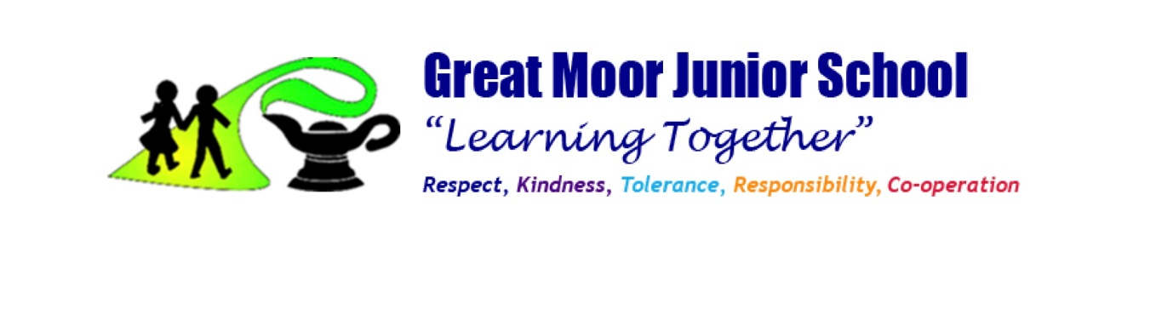

**GREAT MOOR JUNIOR SCHOOL**

**GUIDELINES FOR PSHE.**

This policy is informed by our school’s ethos, which is for all members of the school community to work together to enable all pupils to develop as enthusiastic, confident and skilful learners.

**PSHE (Personal, Social, Health and Economics)**

The provision of PSHE is fundamental to the aims of the school curriculum and the school community. Schools are expected to provide a broad and balanced PSHE Programme through a range of teaching strategies that promote and ensure an inclusive curriculum: delivered through

• speaking and listening

• debate, discussion

• group work

• quizzes, games, problem solving

• case studies

• drama and role play

• specialist speakers to visit school

• out of school visits

PSHE is not only part of a formal curriculum, it is something which permeates the ethos of the school e.g. role models set by staff, respect for children’s homes and cultural backgrounds, the physical environment, people invited into school and the school’s facilities.

**AIMS**

The aims of the PSHE curriculum are to deliver a planned programme of learning through which children and young people acquire the knowledge, understanding and skills they need to manage their lives, now and in the future. As part of a whole school approach, PSHE develops the qualities and attributes pupils need to thrive as individuals and members of society. The benefits to pupils of such an approach are numerous, as PSHE prepares them to manage many of the most critical opportunities, challenges and responsibilities they will face growing up in such rapidly changing and challenging times. It also helps them to connect and apply the knowledge and understanding they learn in all subjects to practical, real-life situations, while helping them to feel safe and secure enough to fulfil their academic potential.

**TEACHING AND LEARNING**

Because PSHE education works within pupil’s real life experiences, at Great Moor Junior School we create a safe and supportive learning environment by establishing clear ground rules, which remain accessible to staff and pupils throughout the year and are referred to regularly.

In the course of the PSHE lessons, if pupils indicate that they are vulnerable or ‘at risk’, staff will refer to our safeguarding policy to ensure clarity about what is required in such circumstances.

Teaching will take in to account the age, ability, readiness and cultural backgrounds of children to ensure that all can fully access PSHE education provision. Careful consideration will be given concerning the level of differentiation needed for children with Special Educational Needs (SEN), and in some cases, the content or delivery will be adapted.

Our PSHE whole school overview outlines key concepts and skills that provide a context for PSHE education at Great Moor Junior School; these are delivered through three main topics: Relationships, Keeping and Staying Safe and Healthy and Living in the Wider World.

**TIMETABLING**

We allocate 45 minutes per week to teach planned PSHE lessons to our pupils. Our provision is further enriched by

* daily/hidden activities such as personal organisation, respect for property and managing relationships with others
* promoting a school ethos that values all individuals, including weekly awards
* school trips, visits and assemblies
* cross-curricular teaching and learning
* circle time
* external visitors – emergency services, bikeability, NSPCC, local MP and local schools etc.
* daily mile

**OUTCOMES AND ASSESSMENT**

The skill of critical reflection is at the heart of assessment for learning in PSHE. Assessment is based on observation throughout all aspects of school life; decision making; behaviour; e-safety; maintaining healthy relationships and looking after our bodies (hygiene, exercise and healthy eating).

At the end of each lesson, the class teacher determines the ability of each child’s understanding on the objective and further input is delivered if required. Effective questioning allows the teacher to build a clearer picture of the child’s understanding with an emphasis on progress and achievement, rather than failure.

The children regularly self-assess, peer assess and reflect on their progress and strengths of the child and how to develop them further are identified. Assessment enables all learners to make progress, achieve and have their efforts recognised.

Our school values, and inclusion of safeguarding within our curriculum is vital as first and foremost, we want our children to be safe and happy so that they can excel in all aspects of school life. Our PSHE curriculum provides them with a chance to reflect and learn about these crucial elements, including sharing policies such as the anti-bullying policy and bringing about awareness of the 9 protected characteristics.

As a result of our PSHE programme, pupils will develop in to self-confident and tolerant members of society, who value their wellbeing and mental health. The skills and attributes they gain whilst learning in our care will support them in navigating themselves throughout modern life and applying these skills to a range of real-life situations. We expect our pupils to leave our school with exposure to a range of global issues, whilst building up tolerance and a sense of responsibility of being a global citizen. Lessons in PSHE will contribute towards respectful, kind, tolerant, responsible and co-operative pupils in line with our school values.

We expect that our pupils will make progress across the wider curriculum through learning and developing resilience to change and challenge and the importance of trying hard, as well as developing positive relationships with trusted adults and peers alike. Pupils will understand the different lifestyles, family structures and differences between themselves and other people and respect differences that contribute towards a diverse society.

Throughout our school, pupils will recognise and demonstrate the British Values of democracy, tolerance, mutual respect, rule of law and liberty.

**Links with other policies**

For specific details about possible related issues e.g. Safeguarding, Bullying, Accessibility, Equality and Diversity,Relationships and Sex Education (RSE) refer to the relevant school policy.