 | Concrete | Pictorial | Abstract
EYFS
To solve problems including halves | 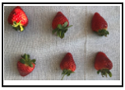  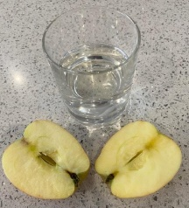  Halves of fruit or drinks and other common items | 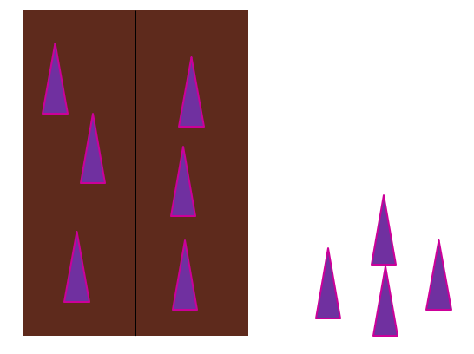
Key Stage 1
Half and share images E.g. put half of the purple spikes on the Gruffalo
To find $\frac{1}{2}$ of a shape | 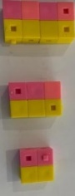  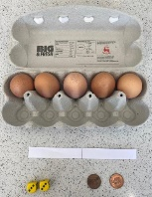  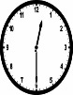  Find half using cubes or everyday items
To find $\frac{1}{2}$ of a number | Find half using cubes or counters | 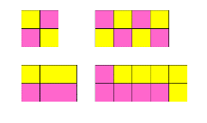  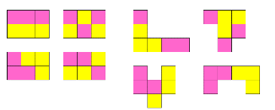  Find half using cubes or counters  Find half of variety shapes in different ways | $\frac{1}{2}$ of 8 = 4  $\frac{1}{2} of 10$ = 5
To find $\frac{1}{4}$ of a shape  To find $\frac{3}{4}$ of a shape | 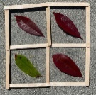  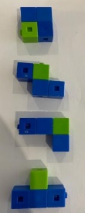  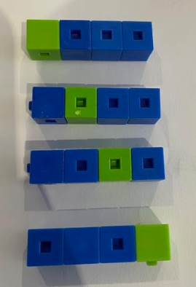  Find quarter using cubes or everyday items and show in different ways | 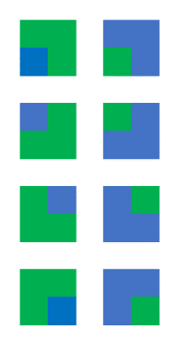  Find quarter using pictures and show in different ways
To find $\frac{1}{4}$ of a number  To find $\frac{3}{4}$ of a number | 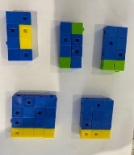  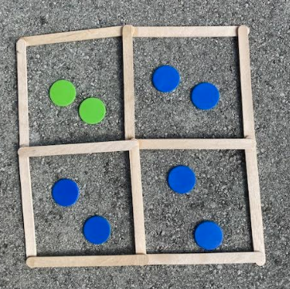  Find quarter using cubes or everyday items and show in different ways | 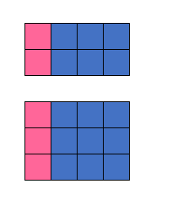  Find quarter using pictures and show in different ways | $\frac{1}{4}$ of 8 = 2  $\frac{1}{4} of 12$ = 3
To find $\frac{1}{3}$ of a shape | 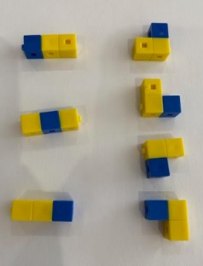  Find third using cubes or everyday items and show in different ways | 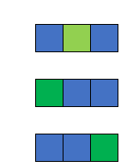  Find third using pictures and show in different ways | Find quarter using abstract form  Find third using abstract form
To find $\frac{1}{3}$ of a number | 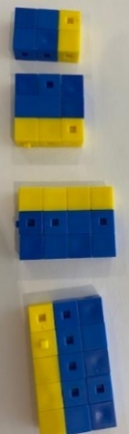  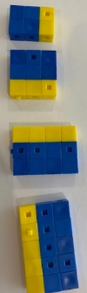  Find third using cubes and show in different ways | 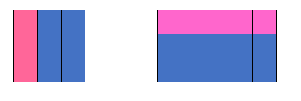  Find third using pictures and show in different ways | $\frac{1}{3}$ of 9 = 3  $\frac{1}{3} of 15$ = 5
Key Stage 2
Recognise, find, and write fractions of a discrete set of objects: unit fractions and non-unit fractions with small denominators | 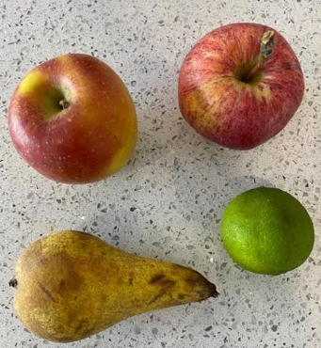  What fraction are apples? Pears? Limes? | 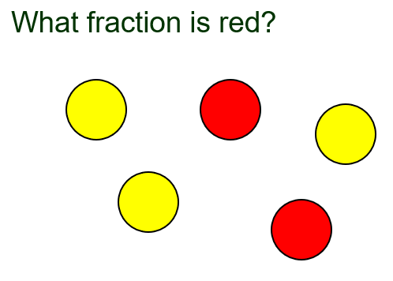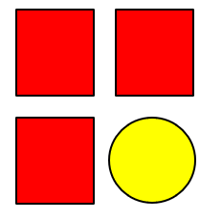  What fraction are square? Circles? | 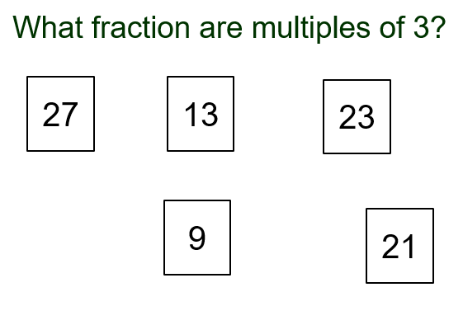
Find unitary fractions of shapes | 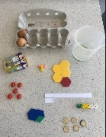  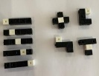  Find unitary fractions using cubes or everyday items and show in different ways | 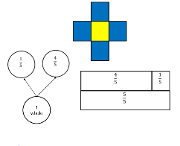  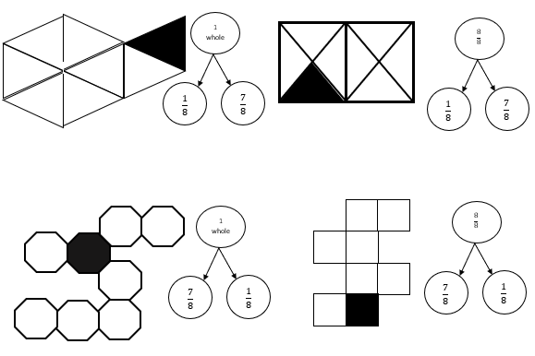  Find unitary fractions using pictures and show in different ways
Find unitary fractions of numbers | 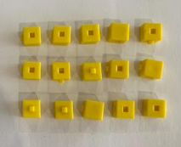  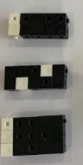  Find unitary fractions using cubes | 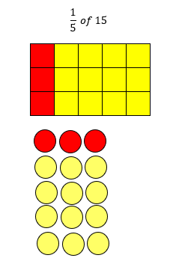  Find unitary fractions using pictures | $\frac{1}{5}$of 25  $$\frac{1}{9} of 27$$  $\frac{1}{6}$ of 18
Find Non-unitary fractions of shapes | 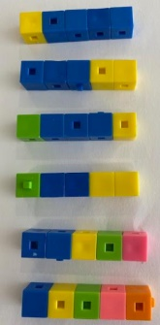  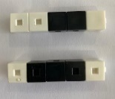  Use part whole models to record what you see | 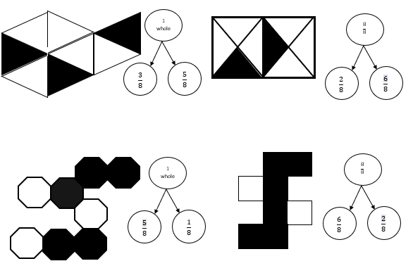  Use part whole models to record what you see
Find Non-unitary fractions of numbers | 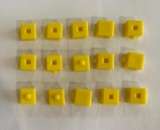  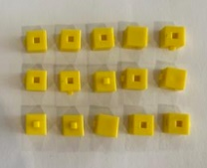  Link the array to a part whole model used folded paper or practical resources | 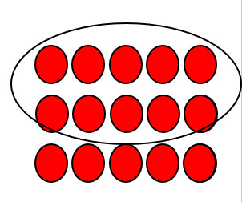$\frac{2}{3}$ of 15  Link the array to a part whole model  5  5  5 | $\frac{2}{3}$ of 15  $\frac{3}{5}$ of 25
Find increasingly difficult non unitary fractions | Find 3/7 OF 42 and 5/6 of 42  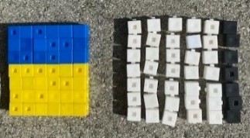  Comapre fraction of same number  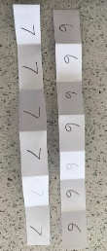 | Find 2/7 of 28 and 5/7 of 63  Compare fractions using same denominator  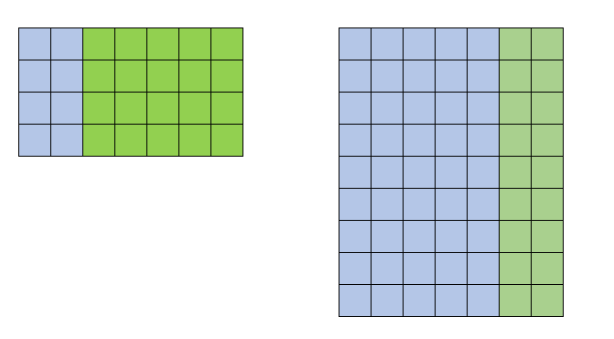  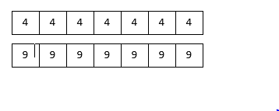 | Compare fractions  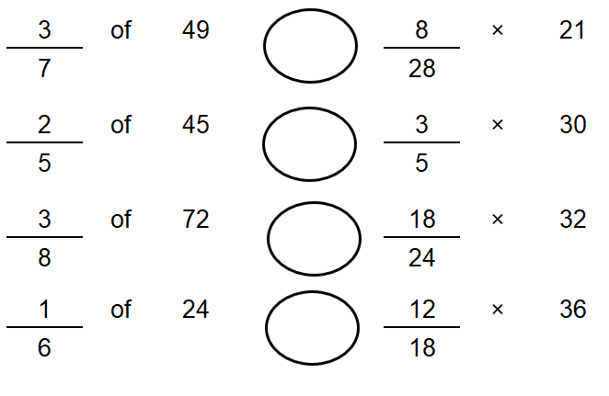
Recognise mixed numbers and improper fractions | 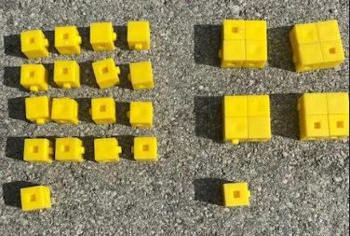 $\frac{17}{4}$  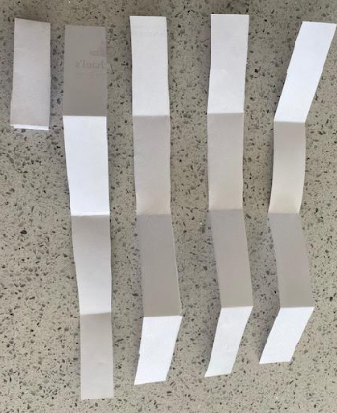 | 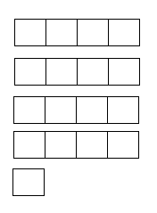 | $\frac{17}{4}$ = 4$\frac{1}{4}$
Use common factors to simplify fractions | 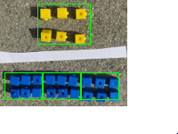 | 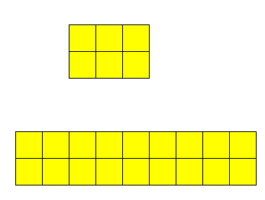 | $\frac{6}{18}$  Find largest common factor of 6 and simplify to $\frac{1}{3}$
Compare and Order fractions
Compare and order unit fractions | 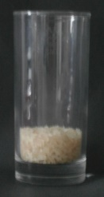  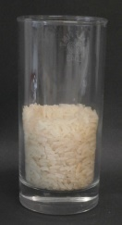 |  | $$\frac{1}{2}$$  Compare $\frac{1}{6}$ and $\frac{5}{6}$  1  0
Compare and order fractions of the same denominator | Compare $\frac{1}{6}$ and $\frac{5}{6}$ | $$\frac{1}{6}$$  $$\frac{1}{6}$$  $$\frac{1}{6}$$  $$\frac{1}{6}$$  $$\frac{1}{6}$$  $$\frac{1}{6}$$  $$\frac{1}{6}$$  $$\frac{1}{6}$$  $$\frac{1}{6}$$  $$\frac{1}{6}$$  $$\frac{1}{6}$$  $$\frac{1}{6}$$  Compare $\frac{1}{6}$ and $\frac{5}{6}$ | $$\frac{1}{4}$$  $$\frac{1}{6}$$  $$\frac{1}{6}$$  1  $$\frac{1}{6}$$  $$\frac{1}{6}$$  $$\frac{1}{6}$$  0  $$\frac{1}{6}$$
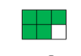
Show both fractions ( $\frac{1}{6}$ and $\frac{5}{6}$ ) on the number line

Compare and order fractions of the same denominator | Compare $\frac{5}{6}$ and $\frac{7}{6}$ | $$\frac{1}{6}$$  $$\frac{1}{6}$$  $$\frac{1}{6}$$  $$\frac{1}{6}$$  $$\frac{1}{6}$$  $$\frac{1}{6}$$  Compare $\frac{5}{6}$ and $\frac{7}{6}$  $$\frac{1}{6}$$  $$\frac{1}{6}$$  $$\frac{1}{6}$$  $$\frac{1}{6}$$  $$\frac{1}{6}$$  $$\frac{1}{6}$$ | 2  1  0  $$\frac{1}{6}$$  $$\frac{1}{6}$$  $$\frac{1}{6}$$  $$\frac{1}{6}$$  $$\frac{1}{6}$$  $$\frac{1}{6}$$  $$\frac{1}{6}$$  $$\frac{1}{6}$$  $$\frac{1}{6}$$  $$\frac{1}{6}$$  $$\frac{1}{6}$$  $$\frac{1}{6}$$
Compare and order fractions of the whose denominators are all multiples of the same number | 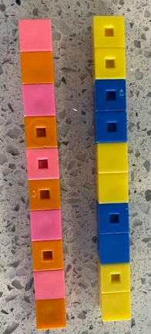 | $$\frac{1}{5}$$  $$\frac{1}{5}$$  $$\frac{1}{5}$$  $$\frac{1}{5}$$  $$\frac{1}{5}$$  $$\frac{1}{10}$$  $$\frac{1}{10}$$  $$\frac{1}{10}$$  $$\frac{1}{10}$$  $$\frac{1}{10}$$  $$\frac{1}{10}$$  $$\frac{1}{10}$$  $$\frac{1}{10}$$  $$\frac{1}{10}$$  $$\frac{1}{10}$$ | 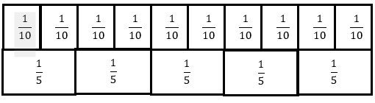  1  0
Compare and order fractions including fractions > 1 |  | Compare $\frac{6}{8}$ and $\frac{7}{9}$  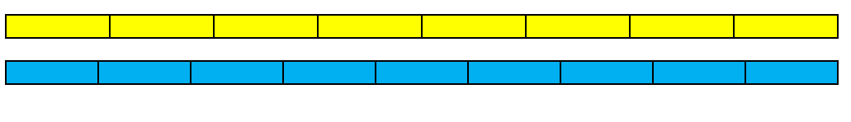 | 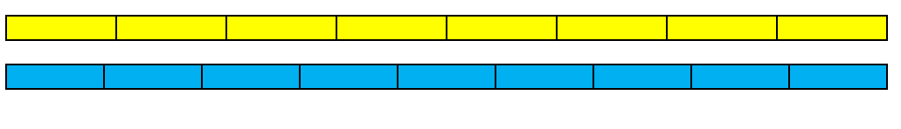  Compare $\frac{11}{9}$ and $\frac{13}{8}$  2  0  1
Equivalent Fractions
Recognise the equivalence of $\frac{2}{4}$ and $\frac{1}{2}$ | 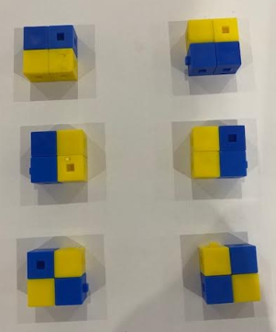 | 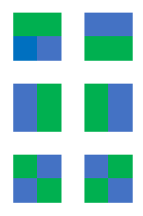 | $\frac{2}{4}$ and $\frac{1}{2}$
Recognise and show, using diagrams, families of common equivalent fractions with small denominators | 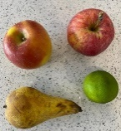 | 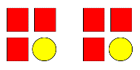
 | 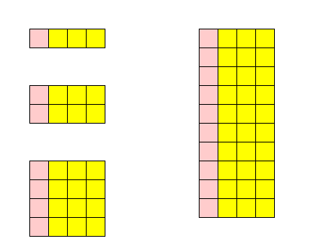  Family of $\frac{1}{4}$ and $\frac{3}{4}$ | 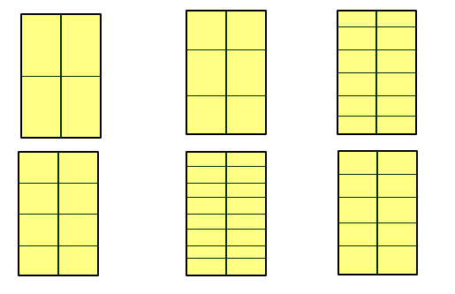  Find a fraction of a shape and cut into equal groups in different ways | 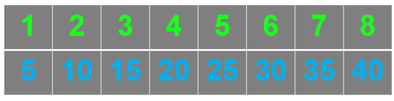  Use double number line
Recognise and show, using diagrams, families of common equivalent fractions | 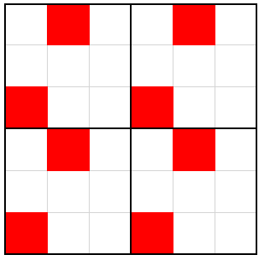  $$\frac{2}{9}=\frac{4}{18}=\frac{6}{27}=\frac{8}{36}$$ | 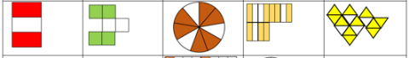  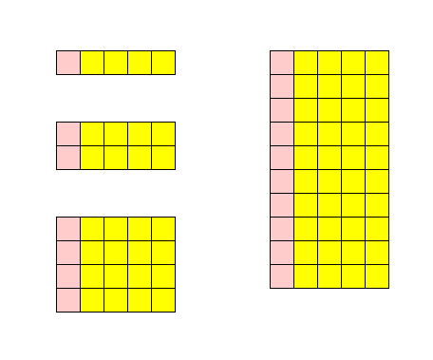  Family of $\frac{1}{5}$ and $\frac{4}{5}$  Family of $\frac{2}{3}$ and $\frac{1}{3}$ | 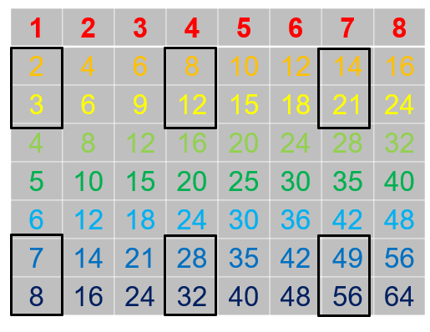  Use multiplication table
Identify name and write equivalent fractions of a given fraction, represented visually, including tenths and hundredths | 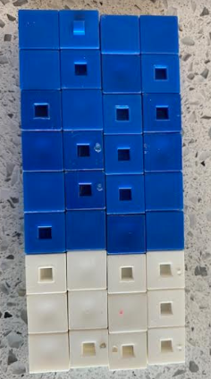  $\frac{12}{36}$ = $\frac{1}{3}$  $\frac{24}{36}$ = $\frac{2}{3}$  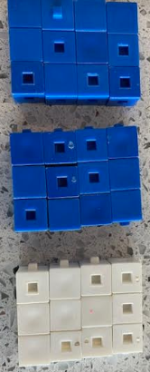 | 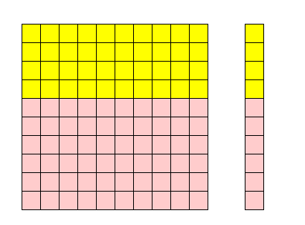  $\frac{40}{100}$ = $\frac{4}{10}$ = $\frac{2}{5}$ | Write fractions that are equivalent to $\frac{3}{5}$  $\frac{30}{50}$ $\frac{60}{100}$ $\frac{120}{200}$  $\frac{15}{25}$ $\frac{21}{35}$ $\frac{27}{45}$
Calculation
Addition and Subtraction of fractions
Add and subtract fractions with the same denominator within one whole | 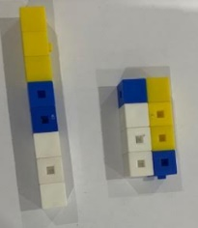  $$\frac{3}{8}$$  $$\frac{2}{8}$$  $$\frac{5}{8}$$ | 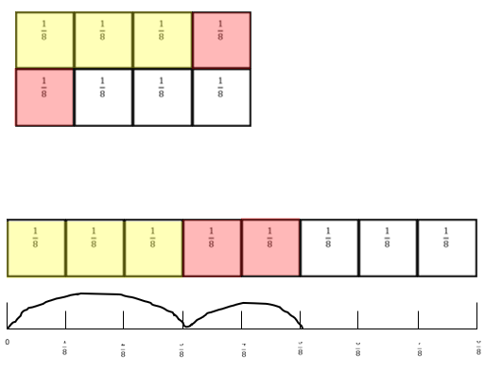$\frac{2}{8}$ + $\frac{3}{8}$ = $\frac{5}{8}$ | $\frac{2}{8}$ + $\frac{3}{8}$ = $\frac{5}{8}$  $\frac{2}{8}$ + $\frac{3}{8}$ + $\frac{3}{8}$ = $\frac{8}{8}$
Add and subtract fractions with the same denominator | 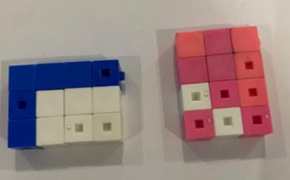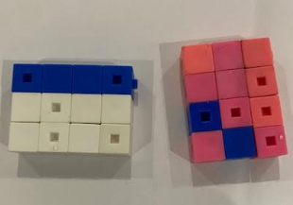  ?  1 $\frac{4}{12}$  $$\frac{10}{12}$$  $$\frac{6}{12}$$  $$\frac{12}{12}$$  $$\frac{4}{12}$$ | 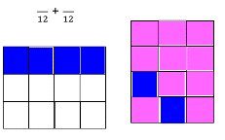  .36+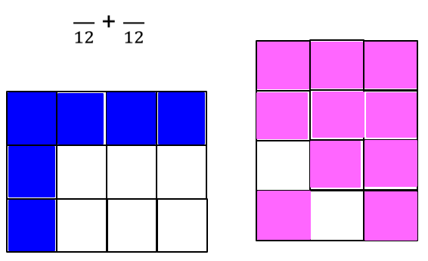  $$\frac{12}{12}$$  $$\frac{4}{12}$$  $$\frac{6}{12}$$  $$\frac{10}{12}$$  $$1\frac{4}{12}$$  ? | $\frac{6}{12}$ + $\frac{10}{12}$ = 1$\frac{4}{12}$  1 $\frac{4}{12}$ = 1$\frac{1}{3}$
Add and subtract fractions with denominators that are multiples of the same number | $\frac{1}{3}$ + $\frac{4}{9}$  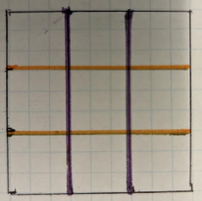  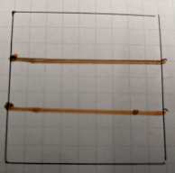  Split into thirds Split into ninths  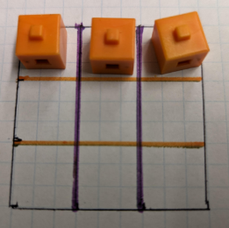  1/3 is the same as 3/9 (remove the cubes)  1/3 = 3/9  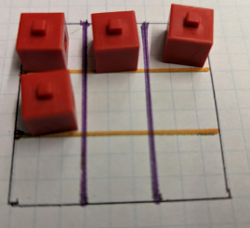  Put on 4/9  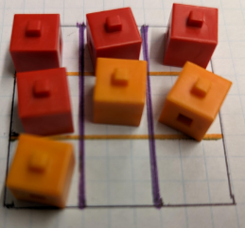  Add them | $\frac{5}{12}$ + $\frac{1}{3}$  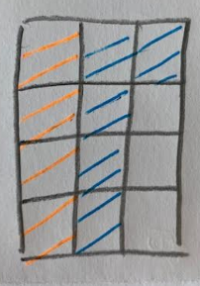 | $\frac{5}{12}$ + $\frac{1}{3}$ = $\frac{3}{4}$
Add and subtract fractions with different denominators and mixed numbers, using the concept of equivalent fractions | 2/3 + 1/4  Split into thirds  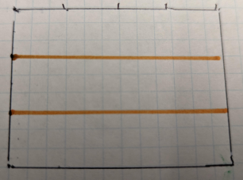  Split into quarters  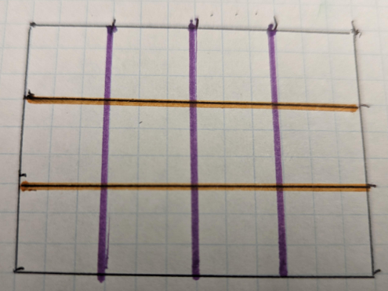  Put on 2/3 and remove  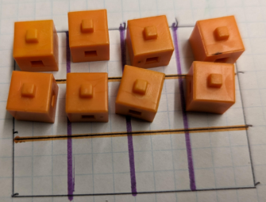  2/3 = 8/12  Put on ¼ and remove  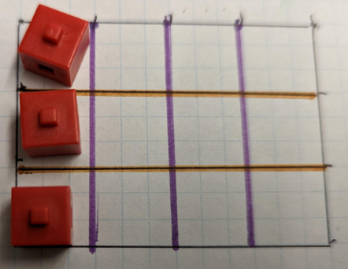  ¼= 3/12  Finally add them  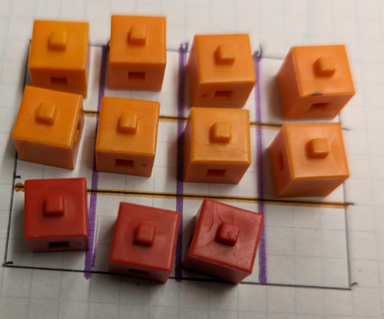  Answer= 11/12 | 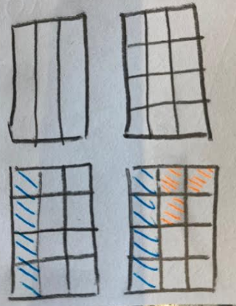 | $\frac{1}{3}$ + $\frac{1}{4}$  $\frac{4}{12}$ + $\frac{3}{12}$ = $\frac{7}{12}$
Calculation
Multiplication and division
Multiply proper fractions and mixed numbers by whole numbers, supported by materials and diagrams | $\frac{1}{4}$ x 5  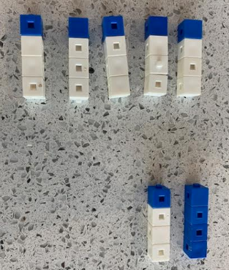 | $\frac{1}{4}$ x 5  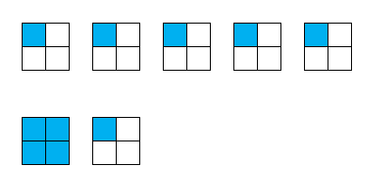 | $\frac{1}{4}$ x 5  $\frac{1}{4}$ + $\frac{1}{4}$ + $\frac{1}{4}$ + $\frac{1}{4}$ + $\frac{1}{4}$ = $\frac{5}{4}$  $\frac{5}{4}$ = 1$\frac{1}{4}$
Multiply pairs of proper fractions, writing the answer its simplest form | 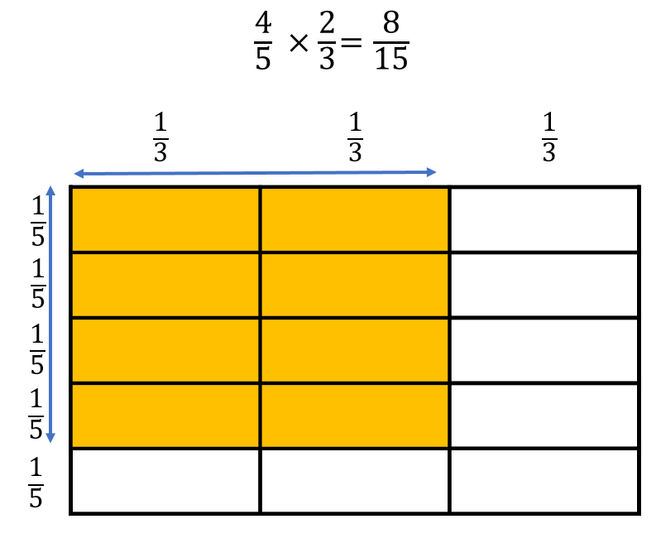 | $\frac{1}{3}$ × $\frac{1}{2}$ = $\frac{1}{6}$ | $\frac{1}{3}$ × $\frac{1}{2}$ = $\frac{1}{6}$
Divide proper fractions by whole numbers | $\frac{1}{3}$ ÷ 2  $\frac{1}{2}$ ÷ 3 | $\frac{1}{3}$ ÷ 2  $\frac{1}{2}$ ÷ 3 | $\frac{1}{3}$ ÷ 2 $\frac{1}{3}$÷ $\frac{2}{1}$ $\frac{1}{3}$ × $\frac{1}{2}$ = $\frac{1}{6}$  $\frac{1}{2}$ ÷ 3 $\frac{1}{2}$÷ $\frac{3}{1}$ $\frac{1}{2}$ × $\frac{1}{3}$ = $\frac{1}{6}$

