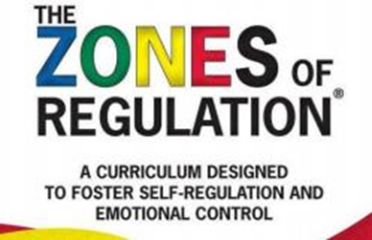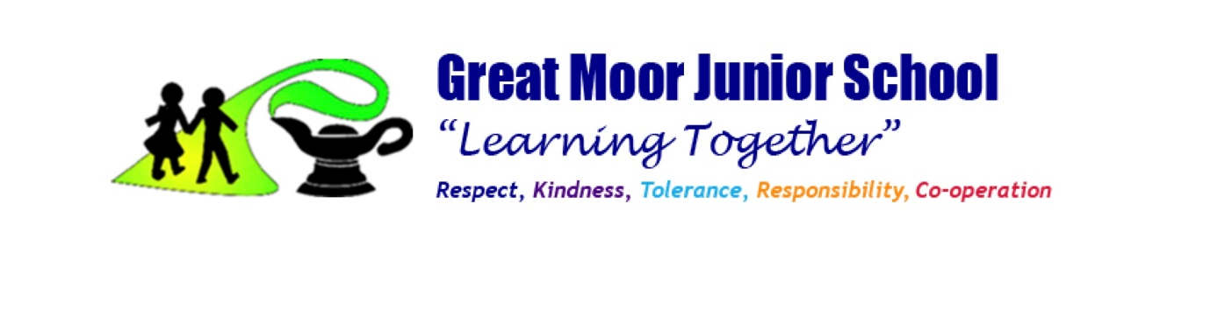

**A Guide to the Zones of Regulation**

The Zones of Regulation is an internationally renowned intervention which helps children to manage difficult emotions, known as ‘*self-regulation’* .

Self-regulation can go by many names such as ‘emotional regulation’, ‘self- control’, ‘impulse management’ and ‘self-management’. Self-regulation is best described as the best state of alertness for a situation, or the ability to maintain a well regulated emotional state to cope with everyday stress and to be most available for learning and interacting.

From time to time, all of us (including adults) find it hard to manage strong feelings such as worry, anger, restlessness, fear or tiredness, and this stops us from getting on with our day effectively. Children who feel these emotions often find it hard to learn and concentrate in school.

The Zones of Regulation aims to teach children strategies to help them to identify their emotions and cope with these feelings so they can get back to feeling calm and ready to learn. These coping strategies are called ‘self- regulation’ At Great Moor Junior School, we want to teach all of our children good coping and regulation strategies so they can help themselves when they experience anxiety and stress.

Using the Zones of Regulation as a framework, we aim to help children to:

   Recognise when they are in the different Zones and learn how to change or stay in the Zone they are in.

   Increase their emotional vocabulary so they can explain how they are feeling.

   Recognise when other people are in different Zones, thus developing better empathy.

   Develop an insight into what might make them move into the different Zones.

   Understand that emotions, sensory experiences such as lack of sleep or hunger and their environment might influence which Zone they are in.

   Develop problem-solving skills and resilience

   Identify a range of calming and alerting strategies that support them (known as their personal ‘toolkit’).

**What are the different Zones?**

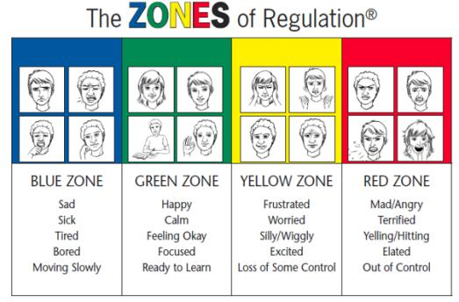

So what are the zones? There are 4 coloured zones to categorise states of alertness and emotional states:

✓ **The Blue Zone** – used to describe low states of alertness, (such as feeling sad, tired, sick or bored. Body/brain is moving sluggishly).

✓ **The Green Zone** – used to describe a regulated state of alertness (such as feeling calm, happy, focussed or content). This zone is generally needed for schoolwork, being social and ready to learn. It shows control.

✓ **The Yellow Zone** – used to describe a heightened state of alertness, but with some control (such as when experiencing stress, frustration, anxiety, excitement, silliness, nervousness, confusion - slightly elevated emotions (being fidgety, wiggly, squirmy or sensory seeking). The person is starting to lose control.

✓ **The Red Zone** – used to describe extremely heightened states of alertness or very intense feelings (such as feeling anger, rage, and explosive behaviour, panic, terror or elation). Not being in control of one’s own body.

You can remember the zones by using a traffic light system.

Like traffic signs;

**Blue** = ‘rest area where you pullover as you aretired and need to recharge’ .

**Green** = the person is ‘good to go’

**Yellow** = ‘caution, slowdown or take warning’

**Red** = ‘stop and regain control’

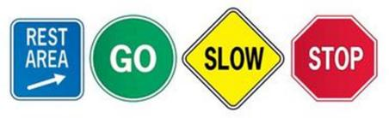

***Important note*** - No zone is ‘bad’ or ‘good’ and we all experience them at one time or another. It is important to avoid reinforcing the idea that red = bad. Often we see with our children that they will indicate they’re in the green zone, even if they’re not.

It is important to validate all emotions, and we should be helping our pupils to identify these emotions.

**Tools and Strategies for Regulation**

There are multiple tools and strategies that our pupils can use to self-regulate – and they will be individual to each child. However, it may be useful to think about the types of activities that will help our children to regulate in each zone.

**Blue Zone Tools:**

✓ Think about what you might do as an adult to make you feel better when you are sad, tired or bored.

✓ This might include talking to a trusted person, breathing, taking a break and relaxing,doing a hobby or importantly, doing some physical exercise.

✓ These exercises should wake up our bodies, recharge and activate our senses and regain our focus. Examples may include: taking a walk, doing some active movement (think jumping, bouncing or swinging).

**Green Zone Tools:**

✓ Think about the strategies you or your child uses to maintain your happiness, alertness in the activity you are engaging in, and calmness.

✓ This may include all of the activities mentioned above, and also pay attention to the environment your child is in – is it safe, calm and enabling of engagement?

**Yellow Zone Tools**:

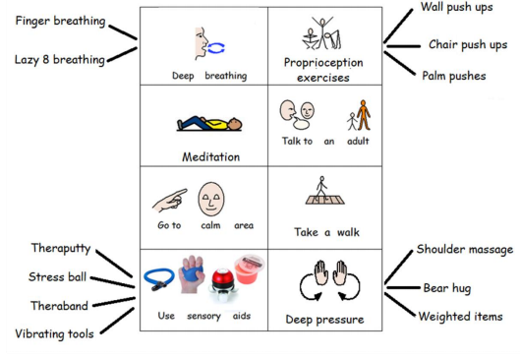✓ When you see your child starting to become heightened, fidgety, over- excited or unfocussed – try to introduce the following calming strategies to prevent an escalation into the Red Zone (or out of control)

**Red Zone Tools**:

✓ Once in the Red Zone, your child will more than likely need to be removed from the situation/setting, and it is encouraged that they go to an environment that is calming and safe.

✓ Calming strategies that ‘power down’ the emotions your child is feeling can be practised here. These include:

o Deep breathing

o Deep pressure/heavy work activities

o Sensory activities – using sensory aids and tools such as theraputty, stress balls, vibrating snakes etc.

o Taking a walk in a quiet place

o Going to a quiet and dark area (i.e. pillow fort/dark tent)

✓ Minimise your language when your child is in the red zone – be clear, concise and calm in your tone.