English | Focus: Grammar/Punctuation/Spelling | Year 3
Spellings I need to learn
accident | consider | grammar | notice | regular
accidentally | continue | group | occasion | reign
actual | decide | guard | occasionally | remember
actually | describe | guide | often | sentence
address | different | heard | opposite | separate
answer | difficult | height | ordinary | special
appear | disappear | history | particular | straight
arrive | early | imagine | peculiar | strange
believe | earth | increase | perhaps | strength
bicycle | eight | important | popular | suppose
breath | eighth | interest | position | surprise
breathe | enough | island | possess | therefore
build | exercise | knowledge | possession | though
busy | experience | learn | possible | although
business | experiment | length | potatoes | thought
calendar | extreme | library | pressure | through
caught | famous | material | probably | various
centre | favourite | medicine | promise | weight
century | February | mention | purpose | woman
certain | forward | minute | quarter | women
circle | forwards | natural | question
complex | fruit | naughty | recent
Expanded noun phrases Try to paint a clear picture in your reader’s head:
She always wore a long black dress, with lace around the bottom…
Place the possessive apostrophe in words with regular and irregular plurals

The cat's tail was fluffy. The brothers' feet were muddy.

The children's toys were broken.
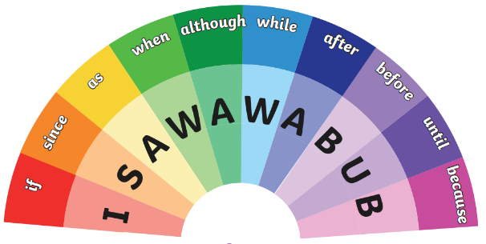

Vocabulary
Adjective | A word that adds more information about a noun.  He opened the large, wooden door.
Adverb | A word that adds more information about verbs, adjectives or other adverbs.  Slowly, he opened the door.
Command | Tells you to do something. Often urgent and short. Get in the car. Stand up.
Exclamation | Usually begin with ‘How’ or ‘What. Ends with an exclamation mark. How exciting! What a lovely day!
Paragraph | A group of sentences about one idea or theme.
Past tense | Verb form used to describe things that happened in the past. I completed my homework last night.
Present tense | Verb form used to describe things happening right now. I work hard on my homework.
Question | Sentences that ask something or show doubts.  Is that your bag? Usually ends with question mark.
Inverted commas | Punctuation used to show what has been spoken or said. “How can I help you?” asked the doctor.
Statement | A sentence that claims something as truth.  My bag is blue. Ends with full stop.

Punctuation Reminders:
A | Capital letters for sentences, initials and proper nouns
. | Full stops
! | Exclamation marks for exclamations or surprise
? | Question marks at the end of a question
‘ | Apostrophes for possession and missing letters in contracted words (omission)
, | Commas in lists, and to mark parenthesis, after fronted adverbials and clauses to make meaning clear
“” | Inverted commas for speech/dialogue (don’t forget other punctuation too!)
Spell word families based on common words, eg: solve/solution/solver
Direct speech opens with inverted commas which are placed around what is being spoken. “I don’t like the zoo!” exclaimed Alfred.
Adverbs | Conjunctions | Prepositions
Then  Next  Yesterday  Soon  Lately  Now | If… Since  As … When  Although…  While… After  Before… Until  Because… | Before  After  During  Above  Below  Besides
Prefixes super- supersonic
anti - anti-bacterial
auto - automatic

