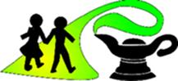
Geography at Great Moor Junior School

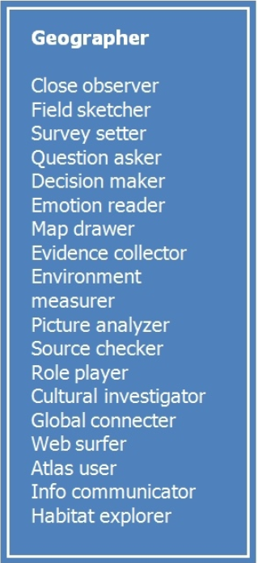
What does a Geography lesson look like in our school?

We believe that a high-quality geography education should inspire a curiosity and fascination about the world and its people that will remain with children for the rest of their lives.
Children enjoy geography and are engaged and challenged.
Children are taught geographical knowledge and skills, building upon previous years’ learning.
There is a field trip in each year group which allows children to learn new skills and knowledge, and allows them to apply these skills. We also carry out fieldwork in each unit that is taught in order for children to develop skills in this area.
Children learn about physical and human geography.
Collaboration in groups and with talk partners is frequent and productive.
Through interactive lessons, children have opportunity to use atlases, globes, O.S. maps, computer programs, apps and games.
Many Geography lessons at GMJS have strong cross-curricular links and these include: English- writing fact files, reports, leaflets, drama and debating; Maths- graphs, direction and scale work; Computing- the use of iPads for research, word processing for presentations, and iPad apps; Science - learning why a place is like it is; History- why people have settled in places; and Art- photography, drawing and painting.
Learning is recorded in a variety of ways in books: leaflets, reports, maps, diagrams and photographs.
Through the introduction of global issues, children learn about the impact they can have on their local environment and the world.
How does Geography work at Great Moor Junior School?
- Geography is taught by class teachers in a modular system, whereby three or four lessons a week, for a half term once a year, are dedicated to the subject.
- Geography topics are set up as an enquiry question for each unit that covers the statutory National Curriculum. Within this are sub questions that lead the children on their learning journey and enable them to develop their knowledge and skills throughout the term.
- Geographical concepts such as Space, Place and Scale are taught throughout the units and work as a thread that runs through all of our work.
- Geography is made explicit in other subjects, whenever possible and relevant.
- The National Curriculum Guidelines for Geography are followed and covered.
- Homework is used to support geography work.

Year Group | Topic
3 | Is the United Kingdom the same all over? (Includes coasts)  Has the landscape and land use of the United Kingdom has changed over time?
4 | Is Europe the same all over?  (Includes mountains, earthquakes and volcanoes)  Why are water and rivers so important?
5 | Where does all our stuff come from?  How is North America similar and different to the North West of England?
6 | What was life like in the Amazon and why is South America so diverse?  Are we damaging our world?

What Assessment takes place?
- Summative assessment is the main tool during and after each lesson.
- Assessment informs the planning for the next lesson.
- The children self and peer assess and reflect on their progress.
- There is a final teacher assessment at the end of each module, with an overall judgement made: emerging, met or exceeding the year group standards. This assessment consists of a final question that the children are asked, where they will apply all the knowledge and skills they have acquired to present their answer.

