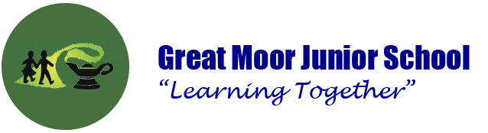

Remote Learning Guidelines for Pupils

These guidelines are to help keep you safe while accessing Google Classroom at home.

I agree that:
I will only Google Classroom and GSuite apps for school work or things I have permission to post. I know that school will monitor my use of Google Classroom.
I will keep my username and password safe and secure and I will not try to use any other person’s username and password.
I will not share any personal information about myself or others when online.
I will immediately report any unpleasant or inappropriate material or messages or anything that makes me feel uncomfortable when I see it online.

Behaviour
I will respect others’ work and property and will not copy any other user’s files, without the owner’s knowledge and permission.
I will be polite and responsible when I communicate with others, I will not use strong or inappropriate language.
I will not take or distribute images of anyone or record any online lessons.
I understand the risks and will not try to upload, download or access any materials which are inappropriate or illegal or may cause harm or distress to others.
I understand that I am responsible for my actions, both in and out of school.
I know that the school’s behaviour rules and Code of Conduct still apply to online learning.

Live lessons
I will keep my camera on at all times during online lessons.
I will only use my Great Moor Junior School account to join lessons or Google Classroom.
I will come to the lesson dressed in suitable clothes and have an appropriate background for others to see.

