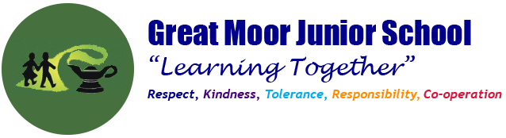

History Mission Statement

The aim of History teaching at Great Moor Junior School is to stimulate the children’s interest and develop an understanding about the lives of people who lived in the past. We teach children a sense of chronology, and through this, they develop a sense of identity and a cultural understanding based on their historical heritage. They learn to value their own and other people’s cultures in a modern, multicultural Britain and by considering how people lived in the past, they are better able to make their own life choices today. As well as teaching children to understand how events in the past have influenced our lives today. We also teach them to use historical skills throughout each topic and to develop these over time. These skills include looking at continuity and change, similarities and difference, interpreting sources, making links and identify the significance of events.

Our objectives in the teaching of History are:

- To foster in children an interest in the past and to develop an understanding that enables them to enjoy all History has to offer.
- To enable children to know about significant events in British history and to appreciate how things have changed over time.
- To develop a sense of chronology.
- To have some knowledge and understanding of historical development in the wider world.
- To help children understand society and their place within it so that they develop a sense of their cultural heritage.
- To develop in children the skills of enquiry, investigation, analysis, evaluation and presentation.
History teaching focuses on enabling children to think as historians. We place an emphasis on providing a rich programme of visits to historic sites and museums for hands-on and living history activities, which brings the past to life and further embeds learning of each historical age. We encourage visitors to come into the school and talk about their experience of events in the past. We aim to foster an understanding that historical events can be interpreted in different ways and that they should always ask searching questions such as ‘How do we know?’’ about information they are given. By Year 6 we aim to have inspired children’s curiosity to know more about the past, by providing children with a range of sources and artefacts to equip them to ask perceptive questions, think critically, weigh evidence and develop perspective and judgement.

